

**DEMONSTRATION PLAN**

**Resource Conservation and Resiliency**

**Comparative Assessment of Total Water Levels for Coastal Military Facility Readiness and Resilience Using Numerical Models – Tyndall Air Force Base (RC21-5028)**

**Jack A. Puleo (University of Delaware)**

**Ahmed Elkut (University of Delaware)**

**Fengyan Shi (University of Delaware)**

**Jens Figlus (Texas A&M University)**

**Joshua Joubert (Texas A&M University)**

**Stephanie Patch (University of South Alabama)**

**Casey Dietrich (North Carolina State University)**

**Jenero Knowles (North Carolina State University)**

**Ellen Quataert (Deltares)**

**July XX, 2024**

**TABLE OF CONTENTS**

Contents

1.0 INTRODUCTION 1

1.1 BACKGROUND 1

1.2 OBJECTIVE OF THE DEMONSTRATION 2

1.3 REGULATORY DRIVERS 2

2.0 TECHNOLOGY/METHODOLOGY DESCRIPTION 3

2.1 TECHNOLOGY/METHODOLOGY OVERVIEW 3

2.1A - Empirical Models 5

2.1B – Delft3D 6

2.1C – ADCIRC 7

2.1D – NEARCOM 9

2.1E – FUNWAVE-TVD 10

2.2 ADVANTAGES / LIMITATIONS OF THE TECHNOLOGY/ METHODOLOGY 12

3.0 PERFORMANCE OBJECTIVES 13

4.0 SITE DESCRIPTION 16

4.1 SITE SELECTION 16

4.2 SITE LOCATION AND HISTORY 17

4.3 SITE CHARACTERISTICS 17

4.4 SITE-RELATED PERMITS AND REGULATIONS 18

5.0 TEST DESIGN 18

5.1 CONCEPTUAL TEST DESIGN 18

5.2 BASELINE CHARACTERIZATION AND PREPARATION 21

5.3 DESIGN AND LAYOUT OF TECHNOLOGY AND METHODOLOGY COMPONENTS 26

5.3.1 Baseline simulations 26

5.3.2 Hurricane Irene: Parameter Alteration 26

5.3.2 Degradation 27

5.4 FIELD TESTING 27

5.5 SAMPLING PROTOCOL 27

5.6 EQUIPMENT CALIBRATION AND DATA QUALITY ISSUES 28

5.6.1 Calibration of Equipment 28

5.6.2 Quality Assurance Sampling 28

5.6.3 Sample Documentation 28

6.0 PERFORMANCE ASSESSMENT 29

6.1 General Statistical Analyses 29

6.2 Specific Approaches for Each Objective 30

7.0 COST ASSESSMENT 35

8.0 SCHEDULE OF ACTIVITIES 38

9.0 MANAGEMENT AND STAFFING 39

10.0 REFERENCES 40

APPENDICES 45

Appendix A: Health and Safety Plan (HASP) 45

Appendix B: Points of Contact 46

**LIST OF TABLES**

Table 1. Pros and cons of the models used in the demonstration. 4

Table 2. Performance objective for the NSN demonstration. 15

Table 3. Setting of Naval Station Norfolk 16

Table 4. Demonstration hurricanes and associated parameters*. 20

Table 5. Degradations applied to the different model simulations. 20

Table 6. Strengths and weaknesses of the ERA5 and Holland model approaches. 21

Table 7. Cost estimates for NSN model simulations. 37

**LIST OF FIGURES**

Figure 1. Schematic showing description of the different components of total water level. 1

Figure 2. Schematic showing added value and model confidence as a function of time and cost 3

Figure 3. Example Delft3D FM output showing surge and tide at Norfolk (star marker) under hurricane forcing. 6

Figure 4. Schematic showing modeling process of Delft3D FM. 7

Figure 5. Schematic showing the preliminary mesh (left) and model results of flooding (right) near NSN in southwest Virginia from ADCIRC. 8

Figure 6. Schematic showing modeling process of ADCIRC 8

Figure 7. The computational grid (left) and an example of modeled surface elevation induced by an extreme storm event at Norfolk (right). 9

Figure 8. Schematic showing modeling process of NearCoM-TVD. 10

Figure 9. Example FUNWAVE output showing nearshore significant wave heights at Norfolk, VA under hurricane forcing. 11

Figure 10. Schematic showing modeling process of FUNWAVE. 12

Figure 11. Satellite imagery of Norfolk (VA, USA) overlayed by color-coded bathymetry showing the shallow water conditions just offshore with water depths < 10 m. Inset shows the study site location (star marker, for reference between the main figure and inset) relative to the wider USA. The track of Hurricane Irene (2011) is shown as the dash-dot curve in the inset 17

Figure 12. Hurricanes and tracks used for the demonstration. 19

Figure 13. Hurricane Irene (2011) shown by the wind fields of the Holland model. Vectors are wind velocities and contours are water levels (m) as computed by ADCIRC. 24

Figure 14. Schematic showing estimate of the timing of model predicted and actual peak surge (Total Water Level Elevation). 30

Figure 15. Schematic showing estimate of the maximum amplitude of model predicted and actual peak surge (Total Water Level Elevation). 31

Figure 16. Schematic showing estimate of the duration of model predicted and actual flooding as a function of Total Water Level Elevation cutoff. 32

Figure 18. Example snip from the preliminary webpage showing flooded area for a storm event. 34

Figure 19. Gantt chart of demonstration activities. 38

Figure 20. Flow chart showing organization of researchers for the demonstration. 39

**LIST OF ACRONYMS**

|  |  |
| --- | --- |
| 1D | One-dimensional |
| 2D | Two-dimensional |
| 3D | Three-dimensional |
| ADCIRC | Advanced Circulation model (Class II) |
| BAA | Broad Agency Announcement |
| CACR | Center for Applied Coastal Research |
| CERA | Coastal Emergency Risks Assessment |
| CoNED | Coastal National Elevation Database |
| CONUS | Continental United States |
| CPU | Central Processing Unit |
| CSHORE | Cross-shore hydrodynamic and sediment transport model (Class II) |
| CUDEM | Continuously Updated Digital Elevation Model |
| Delft3D FM | Deltares 3D hydrodynamic Flexible Mesh model (Class II) |
| DEM | Digital Elevation Model |
| DoD | Department of Defense |
| ECMWF | European Centre for Medium-Range Weather Forecasts |
| ERA5 | ECMWF Re-analysis v5 |
| ESTCP | Environmental Security Technology Certification Program |
| FL | Florida |
| FM | Flexible Mesh |
| FY | Fiscal Year |
| GAHM | Generalized Asymmetric Holland Model |
| GEBCO | Generic Bathymetric Chart of the Oceans |
| GITHUB | Hosting service for software development |
| HM | Holland Model |
| HPC | High performance computer |
| IG | Infragravity |
| IPCC | Intergovernmental Panel on Climate Change |
| lidar | Light detection and ranging |
| MSL | Mean Sea Level |
| NCEI | National Centers for Environmental Information |
| NearCom | Nearshore Community Model (Class II) |
| netCDF | Network Common Data Form |
| NHC | National Hurricane Center |
| NLSWE | Nonlinear Shallow Water Equations |
| NOAA | National Oceanic and Atmospheric Administration |
| NOPP | National Oceanographic Partnership Program |
| NWS | National Weather Service |
| PD | Pressure Drop |
| RC | Resource Conservation and Resiliency (ESTCP program area) |
| RMW | Radius of Maximum Winds |
| RMSE | Root Mean Square Error |
| SERDP | Strategic Environmental Research and Development Program |
| SHORECIRC | Nearshore circulation model |
| SLOSH | Sea, Lake and Overland Surges from Hurricanes model |
| SLR | Sea Level Rise |
| SWAN | Simulating Waves Nearshore model |
| SWL | Still Water Level |
| XBeach-SB | Deltares hydrodynamic model (Class III) |
| TPXO | Global tidal models |
| TVD | Total Variance Diminishing |
| TWL | Total Water Level |
| USA | United States of America |
| USACE | United States Army Corps of Engineers |
| USGS | United States Geological Survey |
| VA | Virginia |
| WGS84 | World Geodetic Survey 84 |
| WIS | Wave Information Study |
| WS | Wind Speed |

**LIST OF VARIABLES**

|  |  |
| --- | --- |
| Bias | Bias between model and data |
| CD | Wind drag coefficient |
| Hrms | Root Mean Square Wave height |
| i | Station location |
| n | Manning’s roughness coefficient |
| N | Number of stations |
| r | Radius |
| R2 | Coefficient of determination |
| RMSE | Root Mean Square Error |
| R2% | 2% runup exceedance |
| Tp | Peak wave period |
| V | Velocity (wind) |
| Vmax | Maximum wind velocity |
| σ | Standard deviation |
| *τ0* | Weighting factor in continuity equation (ADCIRC) |
| ψ | Model parameter being assessed |

# 1.0 INTRODUCTION

## 1.1 BACKGROUND

Projected sea level rise (SLR) and associated storm intensity will cause an increase in total water levels (TWL) at coastal United States (US) military facilities over the coming decades (e.g. GAO, 2019; Hall et al., 2016; UOCS, 2016). Total water levels consist of the mean sea level, high tide, storm surge, and wave-induced runup (Figure 1). Numerous scenarios exist for SLR (IPCC; Hall et al., 2016; Parris et al., 2012; Sweet, et al., 2022) with ranges from 0.2 to 2.0 m over the next 100 years.

SERDP/ESTCP and other entities have funded research efforts for TWL to understand potential risk to military installations, coastlines, and infrastructure (e.g. Burks-Copes and many others, 2014; Donoghue et al., 2013; Hall et al., 2016). Many past efforts focused on single modeling group frameworks (e.g. Burks-Copes et al., 2014) to address these topics. A common framework is the Sea, Lake and Overland Surges from Hurricanes (SLOSH) model used by the National Hurricane Center (e.g. Mayo and Lin, 2019). Typical approaches ignore relevant wave-induced components such as setup, swash (together called runup; Figure 1), and infragravity (IG) motions (Hall et al., 2016). However, operational models do not normally account for runup because of the computational expense. The United States Geological Survey (USGS) and National Weather Service (NWS) are remedying that defect by coupling the [Extratropical Surge and Tide Operations Forecast Systems](http://www.nco.ncep.noaa.gov/pmb/products/estofs/) with empirical runup formulations (<https://coastal.er.usgs.gov/hurricanes/>).

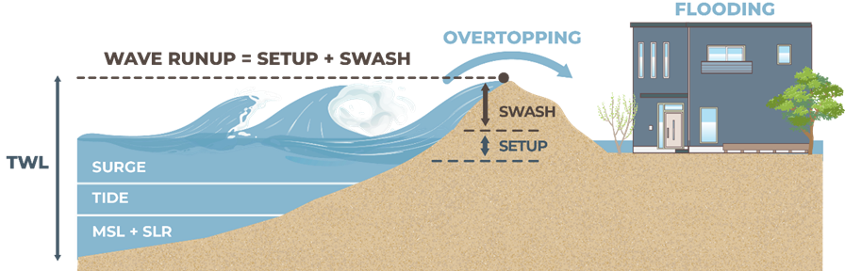

Figure 1. Schematic showing description of the different components of total water level.

Without waves, the underestimation of the TWL can be in excess of 20% (Mayo and Lin, 2019) on shallow sloping coasts and may exceed an order of magnitude on steeper coasts. For example, the largest SLOSH simulation errors (up to 80%) were identified for Hurricane Ernesto at Norfolk, VA (Mayo and Lin, 2019). Similarly, under non-extreme event forcing wave overtopping on shallow sloping beaches was an order of magnitude underpredicted when IG waves were neglected (Lashley et al., 2020). Waves, IG, and other low frequency motions are also important for runup and overtopping on fringing reef‐lined shorelines with steep offshore bathymetry (e.g. Cheriton et al., 2016; Quataert et al., 2020). Most modeling approaches do not account for active morphodynamics. Indeed, Hall et al. (2016) developed a comprehensive regional sea level scenario for over 1800 military installations. They indicate the approach taken in their study does not account for wave motions, non-linear response of storm surge processes, nor active morphodynamics. Yet, altered bathymetry may change the hydrodynamics and erosion during extreme event onset and may exacerbate flooding risk (e.g. Van der Lugt et al., 2019).

## 1.2 OBJECTIVE OF THE DEMONSTRATION

Our objective is to enhance military installation readiness and resilience by performing a comparative assessment of a suite of projection methods for TWL and flooding. Ultimately, demonstrations will be conducted at three military installations spanning a range of geomorphologic and hydrodynamic forcing conditions. **This demonstration is associated solely with Tyndall Air Force Base and associated areas (hereafter referred to as Tyndall)**. Projections will be made using a range of SLR scenarios (Sweet et al., 2022) and other modifications with the main emphasis on TWL induced by hurricane forcing.

The overarching objectives of this demonstration are to assess a range of modeling approaches that include wave, IG, and other nearshore processes, directly simulated or parameterized, to determine applicability, validity, computational cost, and skill in determining TWLs for Tyndall. We will undertake the demonstration to test a range of numerical models for predictions of TWL for Hurricane Michael (2018) as compared to the available in situ and anecdotal data, and then modify Hurricane Michael parameters to determine the impact on TWL. We aim to quantify model predictive capability relative to availability, accuracy, and resolution of forcing and bathymetry information (Figure 2). Additionally, we aim to understand the importance of allowing the bathymetry to change (when possible within model constraints) during the simulations.

## 1.3 REGULATORY DRIVERS

This demonstration project is in direct response to the FY 2021 Statement of Need for the ESTCP Resource Conservation and Resiliency (RC) program area (BAA, Topic area: B6: Coastal Total Water Level Model Comparative Assessment) that calls for efforts to assess presently available empirical, analytical, and numerical models for current and future coastal TWLs. In addition, the Department of Defense (DoD) climate change roadmap (DoD, 2014) identified SLR and storm surge among the top four climate change phenomena that may impact DoD activities.

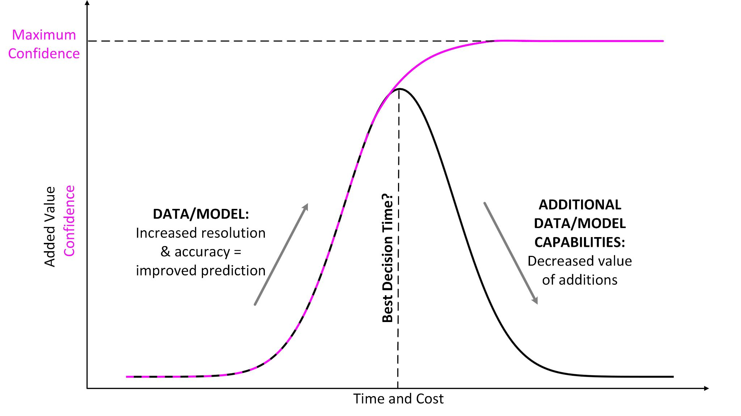

Figure 2. Schematic showing added value and model confidence as a function of time and cost

# 2.0 TECHNOLOGY/METHODOLOGY DESCRIPTION

## 2.1 TECHNOLOGY/METHODOLOGY OVERVIEW

TWLs will be predicted using a suite of simulation models from simple, low-cost empirical to complex, high cost (computation and effort) physics-based. Table 1 provides the proposed list and technical aspects of the models. The modeling approaches can be grouped into three classes. Class I includes empirical approaches that focus on simplified equations for storm surge (Russo, 1998) and runup (Stockdon, et al., 2006). Only the Russo model will be used at this demonstration as the other runup model is not appropriate for this geomorphologic setting. Class II includes (coupled) process-based numerical models such as ADCIRC (Dietrich et al., 2011b; Luettich and Westerink, 2004), NearCom (Chen et al., 2014; Shi et al., 2013), and Delft3D FM (Deltares, 2024). The models are essentially based on the Nonlinear Shallow Water Equations (NSWE) and resolve tides, surges, and statistical wave conditions. The models are dynamically coupled to spectral wave models such as SWAN (e.g. Sebastian et al., 2014). These models (except ADCIRC) have morphodynamics modules to compute sediment transport and bed level changes. Class III includes dynamical wave models. The models used here include: CSHORE (Figlus et al., 2011; Kobayashi et al., 2008a) and XBeach in surfbeat (XBeach-SB; Roelvink et al., 2018, 2009) mode. CSHORE propagates probabilistic representations of hydrodynamic parameters throughout the model domain. XBeach-SB resolves the waves on the group or infragravity time scale.

Table 1. Pros and cons of the models used in the demonstration.

|  |  |  |
| --- | --- | --- |
| **Model** | **Pros** | **Cons** |
| **Delft3D FM (Class II)** | * Well-validated for storm waves and surge * Unstructured meshes allow resolution to vary over several orders of magnitude * Computational efficiency allows simulations over 100’s of kilometers and timescales of several days | * Model resolution limited to tens of meters at critical infrastructure * Does not resolve wave runup |
| **SWAN+ADCIRC (Class II)** | * Well-validated for storm waves and surge * Unstructured meshes allow resolution to vary over several orders of magnitude * Parallel efficiency to tens of thousands of computational cores | * Model resolution limited to tens of meters at critical infrastructure * Does not resolve wave runup |
| **NearCom** | * 2DH with 3D dispersive effect * Consider breaking rollers and undertow | * Analytical solution-based vertical current profile * coupling between wave and current may be costly in the MPI scheme |
| **CSHORE (Class III)** | * Computationally efficient due to depth- and wave-averaged hydro formulations * Beach and dune morphology changes can be computed without major efficiency reduction * Model resolution can be set very high (uniform grid spacing), e.g., 1 m or lower for field simulations | * Includes a number of empirical equations to compute hydrodynamic statistics (including time-averaged runup), bed changes, and sediment transport * Requires input hydro data at a relatively nearshore location (i.e. boundary conditions from Class II models or buoy data) * Only cross-shore (1-D) version used here |
| **XBeach-SB**  **(Class III)** | * Model resolution can be set very high to resolve critical infrastructure (nonuniform grid spacing) * Beach and dune morphology changes can be computed, including dune face avalanching and breaching * Effects of structures can be simulated * Computational demand reduced by not resolving short wave phase | * Model scale limited to kilometers and timescales on the order of storms * Requires input hydro data at a relatively nearshore location (i.e. boundary conditions from Class II models or buoy data) * Does not simulate short wave phase |

### 2.1A – Delft3D FM

Delft3D FM (Figure 3) is an open-source flexible integrated modeling suite, which simulates one-dimensional (1D), two-dimensional (2D; in either the horizontal or a vertical plane) and three-dimensional (3D) flow, sediment transport and morphology, waves, water quality and ecology and is capable of handling the interactions between these processes. The suite is designed for use by domain experts and non-experts alike, which may range from consultants and engineers or contractors to regulators and government officials, all of whom are active in one or more of the stages of the design, implementation, and management cycle. The Delft3D Flexible Mesh Suite (Delft3D FM) is the successor of the structured Delft3D 4 Suite, and it is developed and maintained by Deltares Netherlands as open-source software ([www.deltares.nl](http://www.deltares.nl)).

Delft3D FM allows simulation of the interaction of water, sediment, ecology and water quality in time and space. The modeling suite is mostly used for the modeling of natural environments like coastal, river, and estuarine areas, but it is equally suitable for more artificial environments like harbors and locks. Delft3D FM consists of a number of well-tested and validated modules, which are integrated with one another including D-Flow, D-Hydrology, D-Waves, and D-Morphology (Figure 4). In this demonstration, the D-Flow FM, D-Waves and D-Morphology modules are coupled to simulate the interaction between the hurricane-induced wind, waves, currents, and surge.

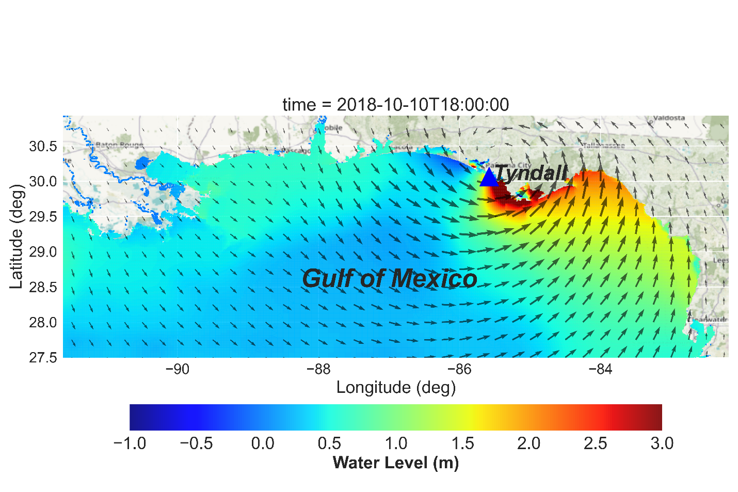

Figure 3. Example Delft3D FM output showing surge, tide and wind (black arrows) at Tyndall (blue marker) under Hurricane Michael forcing.

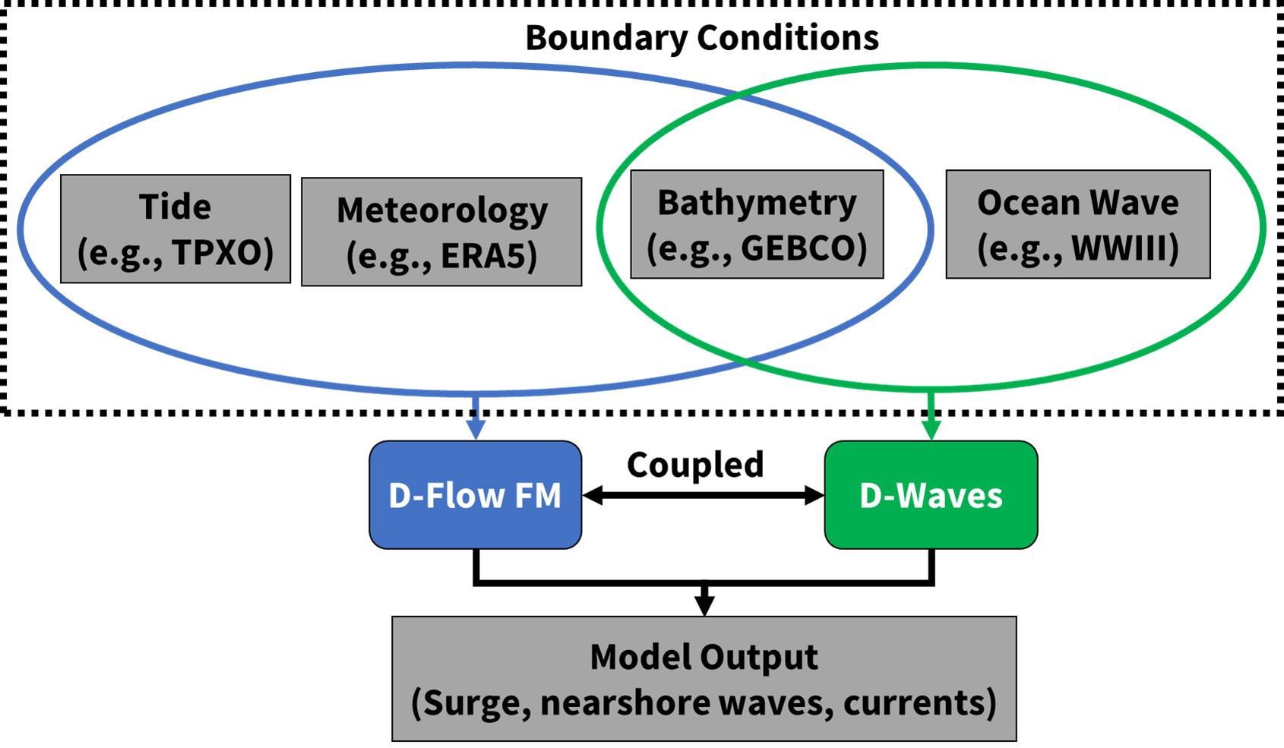

Figure 4. Schematic showing modeling process of Delft3D FM.

### 2.1B – ADCIRC

The ADvanced CIRCulation (ADCIRC; Figure 5) model uses the continuous-Galerkin finite element method to solve modified forms of the shallow water equations on unstructured meshes (Luettich and Westerink, 2004; Westerink et al., 2008). Water levels are calculated using the generalized wave continuity equation, which is a combined and differentiated form of the continuity and momentum equations (Kinnmark, 1986). Depth-averaged current velocities are calculated from the vertically integrated momentum equations. ADCIRC has achieved prominence in storm surge forecasting (Blanton et al., 2012; Fleming et al., 2007), hindcasting (Bunya et al., 2010; Thomas et al., 2019), evaluation and design of protection systems (Ebersole et al., 2007), and development of flood risk maps (FEMA, 2021). ADCIRC has been coupled with the Simulating WAves Nearshore (SWAN) model (Booij et al., 1999; Zijlema, 2010) to yield SWAN+ADCIRC (Dietrich et al., 2011b, 2012). SWAN+ADCIRC has been used operationally to forecast waves and coastal flooding during recent hurricane seasons, with guidance posted online (CERA; 2020;<https://cera.coastalrisk.live>) and shared directly with managers (Rucker et al., 2021).

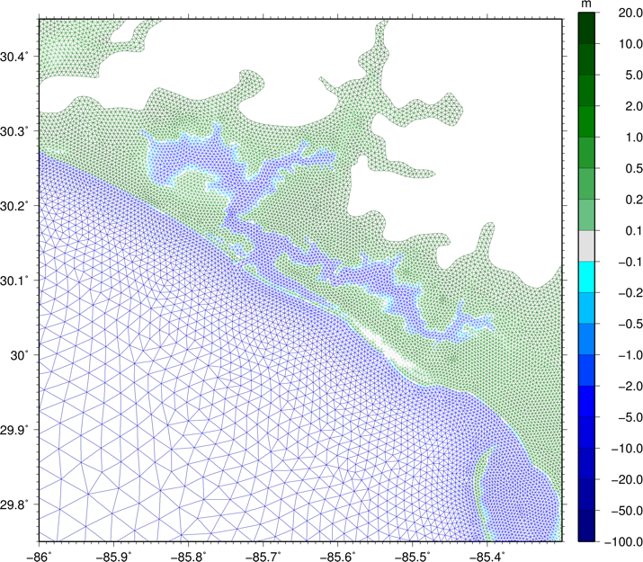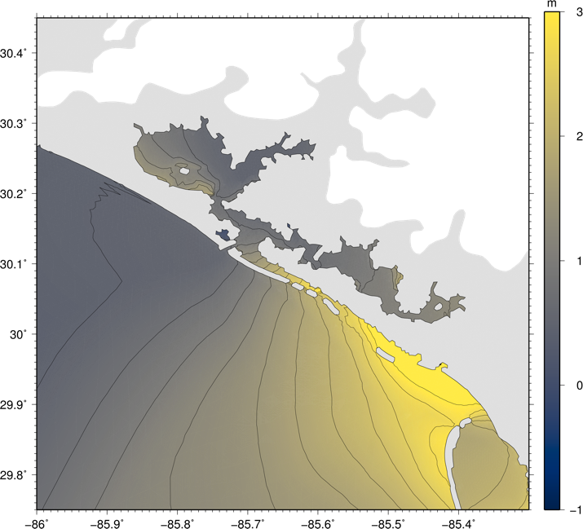

Figure 5. Schematic showing the off-the-shelf mesh (left) and preliminary ADCIRC model predictions of flooding (right) near Tyndall in the Florida panhandle region caused by Hurricane Michael.

ADCIRC uses unstructured meshes with resolution ranging from kilometers in open water, to hundreds of meters near the coastline and through floodplains, and to tens of meters in the small-scale natural and man-made channels that convey surge into inland regions. Early project activities have included simulations with an off-the-shelf mesh for the Gulf coast of Florida (Figure 5), with mesh resolution of about 500 m near Tyndall. A new mesh will be developed for the demonstration with higher resolution near Tyndall. Pre-processing of the new mesh will include identifying digital elevation model (DEM) tiles with higher resolutions near Tyndall while reducing the resolution into the Atlantic Ocean. Using the DEMs, a shapefile will be developed to represent the coastline and floodplains of the mesh to focus only on the Florida panhandle region. With the minimum resolution staged across the domains, most of the elements will be centered at Tyndall. A minimum resolution of 1 km will be used across the northeastern Gulf region and 10 km over the remainder of the mesh. OceanMesh2D (Roberts et al., 2019) will be used to generate these finite element meshes. Workflow for ADCIRC is shown in Figure 6.



Figure 6. Schematic showing modeling process of ADCIRC.

### 2.1C – NearCom

The Nearshore Community Model (NearCom) is an extensible, user-configurable model system for nearshore wave, circulation and sediment processes developed during the National Oceanographic Partnership Program (NOPP). The model consists of a “backbone”; the master program, handling data input and output as well as internal storage, together with a suite of modules, each of which handles a focused subset of the physical processes being studied (Figure 7). A total of 10 modules exist; developed by a large group of researchers from various institutions. Example modules are: 1) A wave module simulates wave transformation over arbitrary coastal bathymetry and predicts radiation stresses and wave-induced mass fluxes; 2) A circulation module simulates the slowly varying current field driven by waves, wind and buoyancy forcing, and provides information on the bottom boundary layer structure; and 3) A seabed module simulates sediment transport, determines the bedform geometry, parameterizes the bedform effect on bottom friction, and computes morphological evolution resulting from spatial variations in local sediment transport rates.

Recently, a new model coupling system called NearCom-TVD (Total Variation Diminishing) was developed based on the MPI-based parallel computing framework. NearCom-TVD couples a nearshore circulation model, SHORECIRC, using a hybrid finite-difference finite-volume TVD-type scheme on a generalized curvilinear grid, the wave model SWAN, and several selectable sediment transport modules (e.g. Kobayashi et al., 2008; Soulsby, 1997; Van Rijn et al., 2011) as shown in Figure 7. NearCoM-TVD is the standard version open to public and maintained in the GITHUB repository. NearCom-TVD is an open source code maintained in GITHUB with report (Chen et al., 2014; Shi et al., 2013) and online (WIKI page: [h](https://fengyanshi.github.io/NEARCOM-TVD/WIKI/_build/html/index.html)ttps:// fengyanshi.github.io /NEARCOM-TVD /WIKI/ _build/ html/index.html) documentation.

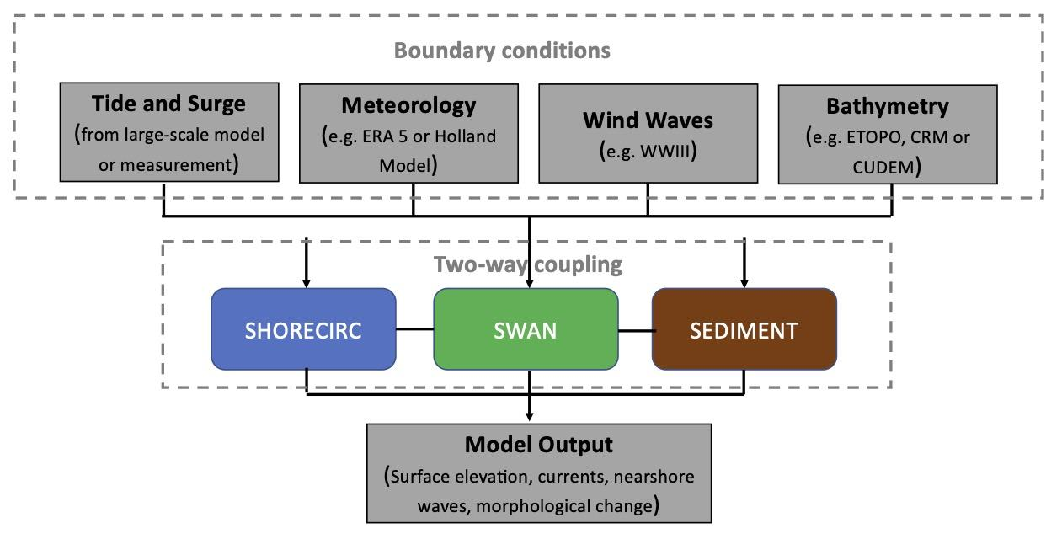

Figure 7. Schematic showing modeling process of NearCom-TVD.

### 2.1D – CSHORE

CSHORE is a very efficient process-based 1D cross-shore coastal response model (Kobayashi and Zhu, 2022). The model includes a time-averaged and depth-averaged combined wave and cross-shore current model, a time-averaged sediment transport model, a probabilistic model for the intermittently wet and dry zone, as well as empirical formulas for irregular wave runup (Kobayashi et al., 2008) and the computation of overtopping and overwash of dunes (Figlus et al., 2011) and structures. The model employs a linear wave theory-based model with an assumed Gaussian distribution of the free-surface elevation below mean sea level (MSL) and a model based on the time-averaged continuity and momentum equations derived from nonlinear shallow-water equations above still water level (SWL) to provide hydrodynamic forcing for sediment transport and morphology changes. Figure 8 shows a schematic of the CSHORE modeling process. Computational efficiency, robustness, and relatively good accuracy are some of the major advantages of using CSHORE as a tool to predict beach profile changes, runup, overtopping, and overwash.

CSHORE predicts cross-shore variations of the mean and standard deviation of the free surface elevation, the depth-averaged cross-shore current, the cross-shore velocity standard deviation, the cross-shore bed-load transport rate, and the cross-shore suspended sediment transport rate, and the bed level.

The root-mean-square wave height, spectral peak period and setup/setdown with respect to SWL are used as input at the offshore boundary of the computation domain. Optional inputs include tidal fluctuation and wind. Only the initial bottom profile elevation is specified for the computation of the entire model run. Since CSHORE is a 1D cross-shore time-averaged model, it is most effective when applied to representative shore locations where bathymetric contours are approximately parallel.

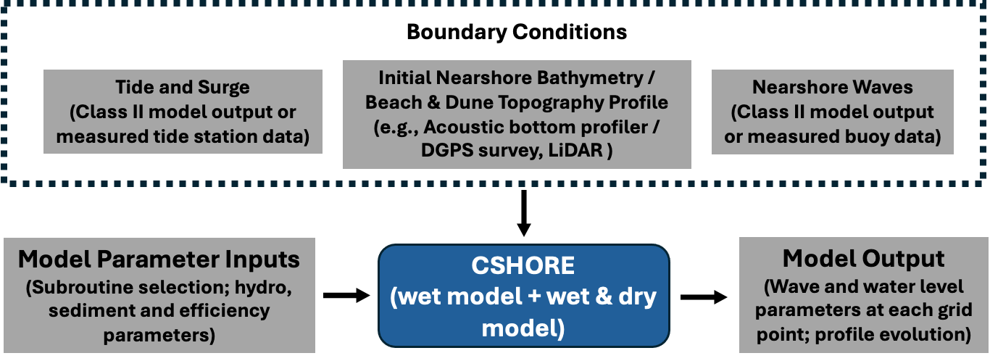

Figure 8. Schematic showing modeling process of CSHORE.

Figure 9 shows an example of shore-perpendicular CSHORE profile transects set up every 1 km along a 70-km stretch of the Florida Gulf Coast surrounding Tyndall ranging from Mexico Beach, FL, to Laguna Beach, FL. Maximum input water levels to the model based on Hurricane Michael ADCIRC simulations (Bilskie et al., 2022) are indicated by the colored dots at the offshore end of each profile line, respectively. The track of Hurricane Michael (2018) is shown as a green dashed line.

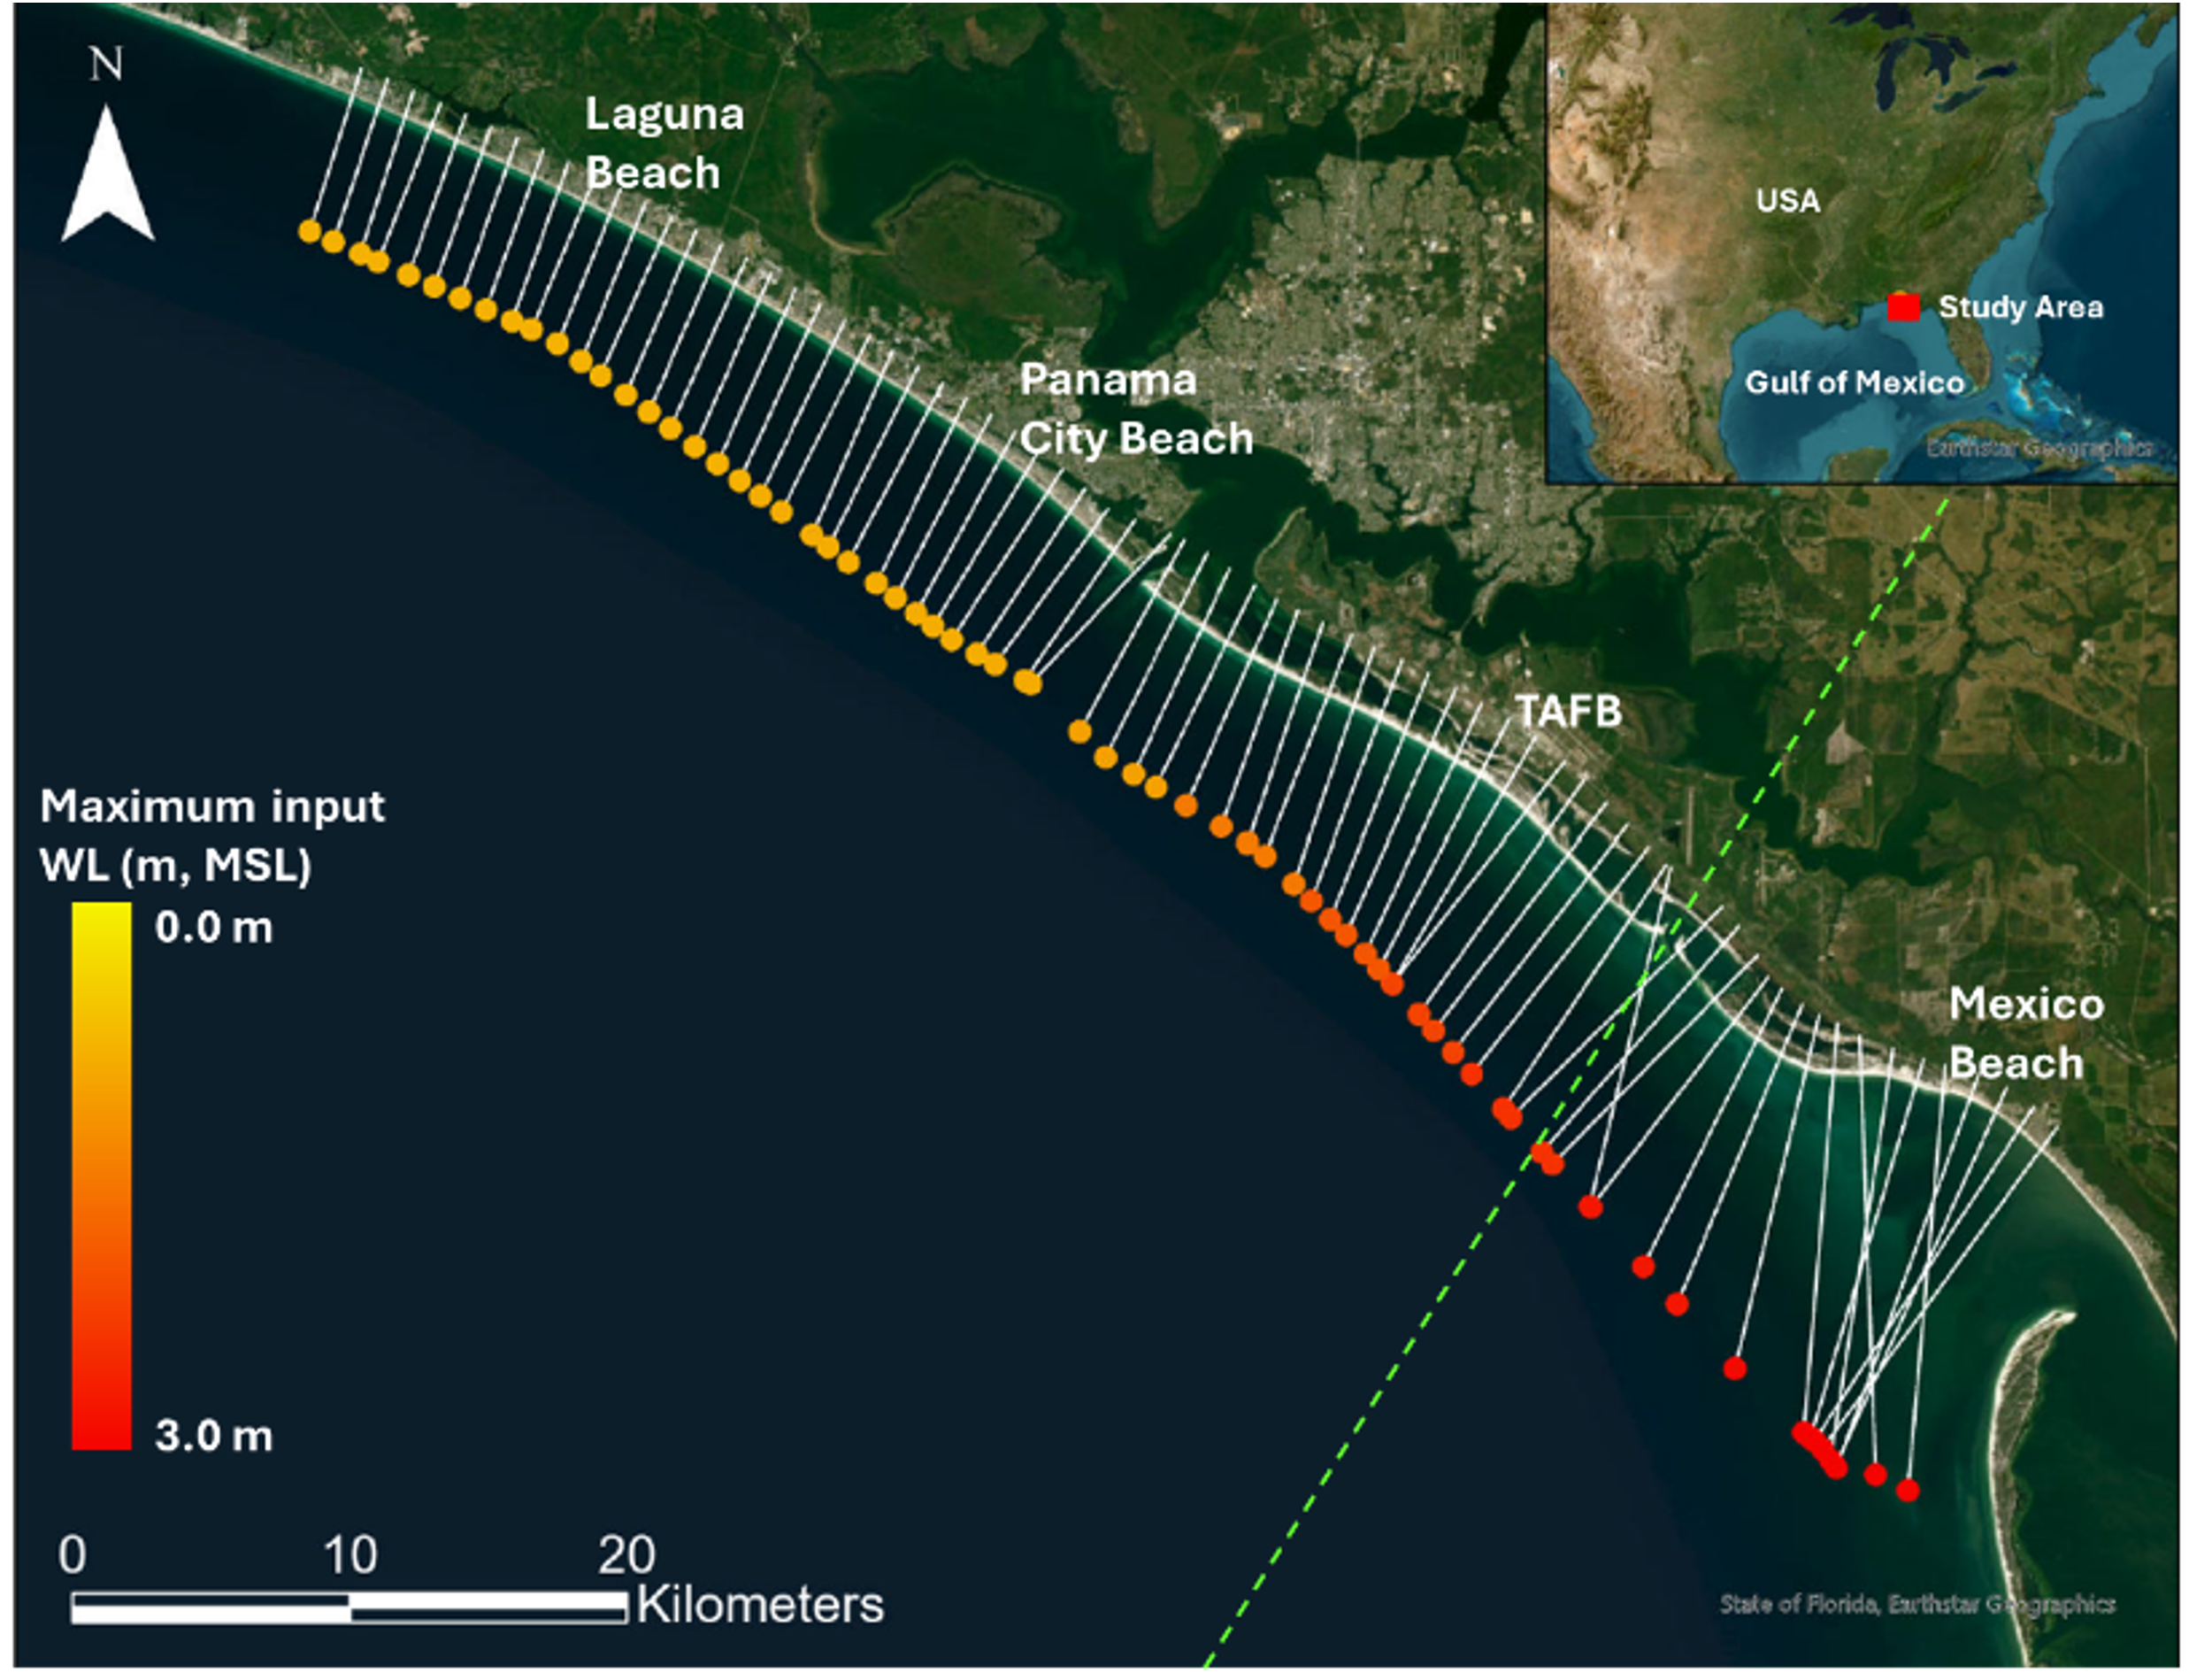

Figure 9. Study area of TAFB and Mexico Beach, with white lines indicating CSHORE profile transects, colored dots indicating maximum input water levels from ADCIRC simulations, and green dashed line indicating the path of Hurricane Michael.

An example CSHORE output is given in Figure 10 where the blue solid line indicates the modeled water level across a 1-km section of a cross-shore profile at Mexico Beach, FL at the peak of Hurricane Michael impact. Black crosses show high water marks recorded in the field (USGS, 2018).

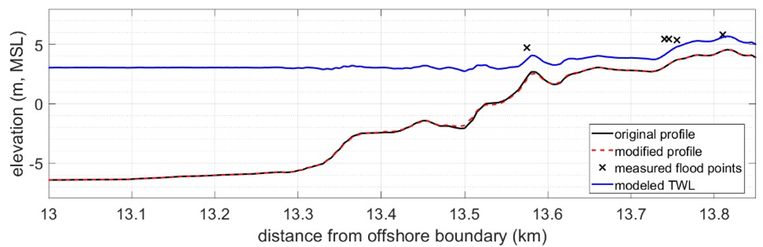

Figure 10. Example of modeled CSHORE run for Mexico Beach at the peak of Hurricane Michael water level impact, zoomed into the coastal area. Model spacing 5 m, time step 20 minutes.

### 2.1E – XBeach-SB

XBeach is a process-based, open-source numerical model capable of simulating hydrodynamics and morphodynamics over complex bathymetry (Roelvink et al., 2018, 2009). XBeach model skill has been demonstrated on sandy barrier islands (Lindemer et al., 2010; McCall et al., 2010; Shambach et al., 2018; Van der Lugt et al., 2019), urbanized coasts (Smallegan et al., 2016; Van Verseveld et al., 2015) and gravel beaches (McCall et al., 2015). The 2D depth-averaged model can be executed in surfbeat mode (XBeach-SB) or non-hydrostatic mode (XBeach-NH). Only the surfbeat mode is used in this demonstration.

XBeach-SB (Figure 11) resolves the short-wave envelope without phase information, thereby reducing resolution and computation time requirements. The nonlinear shallow water wave equations calculate low frequency and mean flows. A wave action balance equation is coupled with a roller energy balance equation to determine radiation stress gradients. Sediment transport is modeled using a depth-averaged advection diffusion equation where sediment entrainment and deposition is determined by the difference between the depth-averaged and equilibrium sediment concentrations. Bed levels are updated according to gradients in sediment transport rates and an avalanching term to model dune slumping that uses critical bed slopes for wet and dry grid cells.

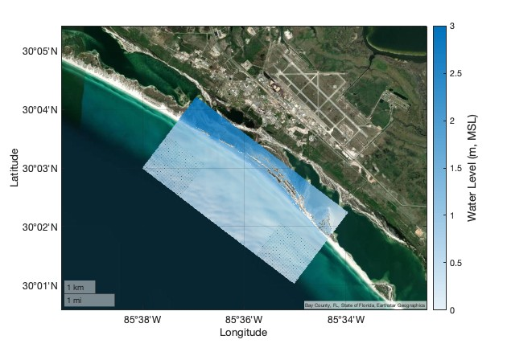

Figure 11. Example XBeach-SB output showing inundation and water levels during Hurricane Michael on the barrier island in front of Tyndall.

XBeach has been validated with a wide range of analytical, laboratory, and field test cases using a standard set of parameter settings. The hydrodynamic modules can simulate sea-swell wave transformation (refraction, shoaling, and breaking), low-frequency wave (infragravity wave) transformation (generation, propagation, and dissipation), wave-induced set-up, unsteady currents, and overwash and coastal flooding. The morphodynamic modules simulate bed load transport, suspended load transport, bed level changes, and all four dune impact regimes as defined by Sallenger (2000). These hydro- and morpho-dynamic processes can also be simulated around structures and on vegetated coasts. Coastal structures are represented as “non-erodible” grid cells such that changes in elevation at or below the specified structure elevation are not allowed to occur. Vegetation can be included by specifying the type and location. The process for running XBeach-SB is shown in Figure 12.

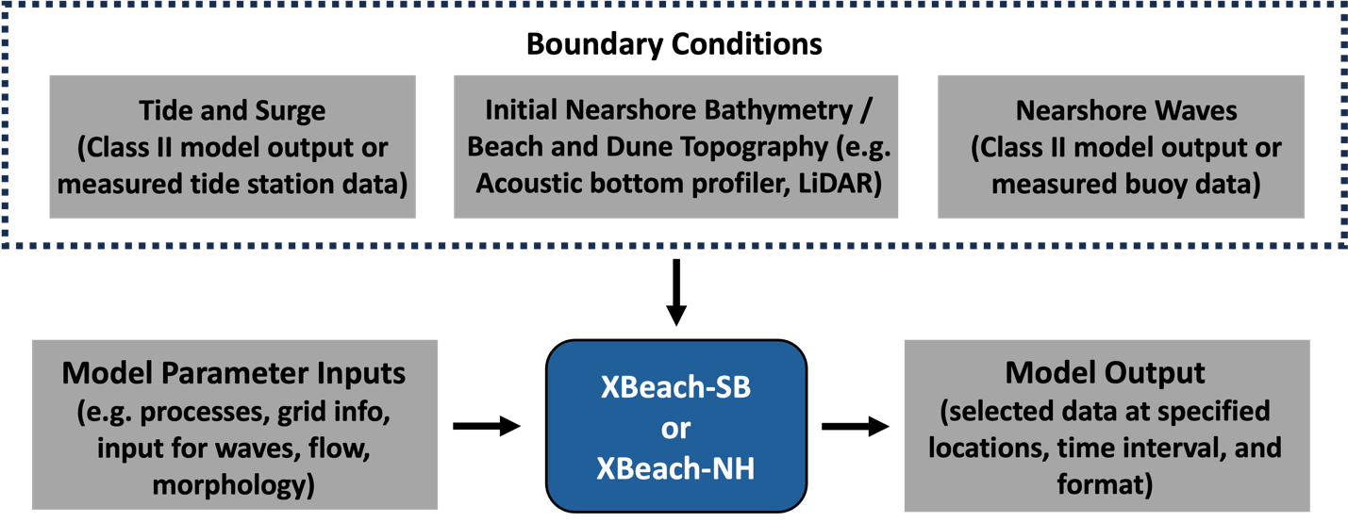

Figure 12. Schematic of the modeling process for XBeach-SB.

## 2.2 ADVANTAGES / LIMITATIONS OF THE TECHNOLOGY/ METHODOLOGY

The demonstration seeks to determine suitability of a variety of prediction tools and identify ability to reach certain performance metrics. Of course, there are trade-offs depending on the numerical model used, the accuracy and output sought, the computational need, and manpower cost (Table 1); the latter related to expertise and experience with a particular modeling approach. The different Class II models used are similar in their output and cost. The three models have been validated under a range of scenarios by the scientific and engineering community. However, the models lack the ability to resolve waves well. The Class III models tested in this demonstration resolve a representation of the wave field, have high spatial and temporal resolution. They cannot resolve tide and surge and require Class II models to provide nearshore boundary conditions for model forcing. CSHORE is an exception in that it is a depth- and time-averaged, process-based 1D model with the ability to compute and propagate hydrodynamic statistics quickly along an initial bed profile from the offshore model boundary to the shoreline and the beach and dune. It employs a probabilistic approach to compute parameters rather than resolve wave motions which makes it very computationally efficient – even at high spatial resolution and with the inclusion of bed updating.

There are numerous other numerical models used for hydrodynamic predictions; and only a subset can be realistically tested in this demonstration. For example, the Class II models (Delft3D FM, ADCIRC) share similar strengths and weaknesses to other models in this class. For example, one similar model is SLOSH which is used extensively by the U.S. National Weather Service (NWS) to estimate storm surge heights resulting from hurricanes (Jelesnianski et al., 1992). SLOSH solves simplified forms of the shallow water equations on a polar, elliptic, or hyperbolic grid, telescopic outward with a finer resolution near the center (coastline). SLOSH storm surge predictions depend strongly on accurate meteorological input such as hurricane size, intensity, forward speed, trajectory, and atmospheric pressure (Forbes et al., 2014). SLOSH-based models are computationally efficient and are used for ensembles of predictions in real-time and for climatological surge studies (Glahn et al., 2009; Zachry et al., 2015). SLOSH’s strength is its efficiency; a SLOSH simulation can be carried out in a few minutes on a single computational core once bathymetry and forcing conditions are available. Thus, SLOSH can be applied for ensemble simulations to account for uncertainties in storm predictions. However, SLOSH’s weaknesses include a relatively coarse model resolution that limits the accuracy in any single simulation, and it has only recently been extended to include tides and wave coupling.

# 3.0 PERFORMANCE OBJECTIVES

This demonstration project will test a variety of performance objectives related to numerical model setup and simulation, accuracy of prediction, timing of prediction, and spatial extent of TWL-induced flooding at Tyndall (Table 2).

Objective 1: We will document the time required to develop the model bathymetry from DEMs and the forcing boundary conditions. This effort should take no more than, 4 weeks for Class II and Class III models. Note: Time estimates are developed based on preliminary trials already conducted and individual expertise on corresponding models. Model development at new DoD installations may require additional time associated with data gathering, DEM generation, and input file formulation. However, we envision that model experts will be able to conduct initial simulations at other DoD installations within a factor of 2X the time estimates provided in Table 2. Variations in effort are related to differences in bathymetry (complex vs simple) and differences in available data resolution in space and time. Subsequent simulations at Tyndall and other DoD installations will then require less time to conduct as the DEM will not need to be modified.

Objective 2: We will document the run time and computational architecture (see section 7) used to conduct the various simulations. There is no universal approach for comparison because simulations are architecture-dependent. Thus, we aim to complete a particular simulation, at the highest resolution, in no more than 24 hours for Class II and Class III models. Note that completing a particular simulation may include an iterative process of running simulations, examining errors, refining model forcing, and running the subsequent simulation extending beyond the time frames identified here.

Objective 3: We will quantify the model skill in predicting the timing of peak surge using available tide station data. The predicted time of peak surge should be ± 3 hours of the actual time of peak surge.

Objective 4: We will quantify the model skill in predicting the magnitude of peak surge using available tide station data. Model root mean square errors (RMSE) should be less than 20% for the simulations.

Objective 5: We will quantify the model skill in predicting the duration of a particular flooding level using available tide station data. The predicted duration of a particular flooding level should be ± 3 hours of the actual duration.

Objective 6: We will identify flooded spatial area as a function of time and flooded depth and compare the results to available data.

Objective 7: We will conduct “degradation simulations” to the base model simulation to quantify prediction error when there is a deficit of information (resolution and/or accuracy). There is no performance metric. However, these simulations provide critical information on prediction confidence when input and forcing data are imperfect (always the case in a predictive scenario). The range of degradation simulations are provided in Section 5.1.

Objective 8: Model simulation results will be provided as layers in a webpage format for program manager review. The qualitative metric is related to ease of use and ability for technical-level personnel to understand and use the data. The webpage is slated to be completed 3 months after submission of the demonstration report.

Table 2. Performance objective for the Tyndall demonstration.

|  |  |  |  |
| --- | --- | --- | --- |
| **Performance Objective** | **Metric** | **Data Requirements** | **Success Criteria** |
| **Quantitative Performance Objectives** | | | |
| 1. Model setup | Quantify time required to generate DEM and boundary conditions | Database supplied bathymetry, wind or storm parameters, waves, offshore water level | < 8 weeks |
| 1. Model run time | Quantify time required to conduct simulation as a function of architecture | Time and computational resource used | < 24 hours (Class II)  < 36 hours (XBeach-SB; single CPU)  < 0.1 hours (CSHORE) |
| 3) Test models’ capability in predicting the timing of peak surge | Comparison with available water level data and reference full physics model runs when possible | Water level data from multiple tide stations | ± 3 hours of actual timing |
| 4) Test models’ capability in predicting the magnitude of peak surge | Comparison with available water level data and reference full physics model runs when possible | Water level data from multiple tide stations | < 20% RMSE |
| 5) Test models’ capability predicting the duration of particular TWL | Comparison with available water level data and reference full physics model runs when possible | Water level data from multiple tide stations | ± 3 hours of actual duration |
| **Qualitative Performance Objectives** | | | |
| 6) Test models’ capability predicting the spatial extent of flooding for a particular depth and timing | Comparison with available anecdotal data of flooding and reference full physics model runs when possible | Available data from reports (note anecdotal data will be incomplete) | Express value in comparing the different model output of flooding extent |
| 7) Model degradation simulations | Importance of resolution and accuracy of model inputs and forcing | Model data from different simulations | Quantification of the model output relative to the base simulation with “perfect” inputs |
| 8) Web interface: Ease of use | Ability of technical-level personnel to use/understand output | Personnel feedback on interface | Technician-level personnel can select results suitable for the installation |

# 4.0 SITE DESCRIPTION

## 4.1 SITE SELECTION

Tyndall Air Force Base was chosen as the second of three sites for the overall ESTCP project to provide an end member of geomorphological setting and hydrodynamic forcing (Table 3). The geomorphological setting with a wide continental shelf would suggest that waves have less importance than surge. However, this concept has not been quantified at Tyndall. Similarly, Tyndall experiences hurricane forcing, and possible differing magnitudes of bay surge from Saint Andrew Bay and Saint Andrew Sound separated by a semi-connected barrier island making it a suitable location to test model capability under these forcing scenarios.

Table 3. Setting of Tyndall Air Force Base.

|  |  |
| --- | --- |
|  | **Tyndall Air Force Base** |
| **General Location** | Gulf Coast, FL |
| **Geomorphic Setting** | Semi-connected barrier island fronted by wide continental shelf |
| **Primary forcing** | Microtidal, mild wave climate, ocean and bay side flooding, hurricanes |

## 

## 4.2 SITE LOCATION AND HISTORY

Tyndall Air Force Base is located on the Gulf of Mexico in the Florida panhandle near Panama City (USA) (Figure 13). Tyndall has approximately 200 km of coastline along Saint Andrew Bay to the east, Saint Andrew Sound to the west, and is backed by East Bay to the north. Most of the base has elevations within 5 m of mean sea level, leaving it vulnerable to the impacts of SLR and surge during tropical storms.

On 10 October 2018, Hurricane Michael (<https://www.nhc.noaa.gov/archive/2018/MICHAEL.shtml>) made landfall as a Category 5 hurricane in Mexico Beach, FL, located less than 10 km from Tyndall. Minimum pressure and maximum wind speeds for Hurricane Michael were measured near Tyndall, with pressure reaching 919 mb and wind speeds up to 72 m/s (Beven et al., 2019). At the coast, Michael produced storm surge up to 4.69 m above MSL and significant wave heights up to 8.69 m (Beven et al., 2019; Schönau et al., 2024). Inland areas faced heavy rainfall and high winds. Hurricane Michael was directly responsible for 16 deaths (49 deaths in total) and about USD 31 billion in damage in the United States (Beven et al., 2019; <https://www.ncei.noaa.gov/access/billions/>). Tyndall experienced significant flooding and damage to every building on base, with initial damage estimates on the order of USD 3 billion (Beven et al., 2019).

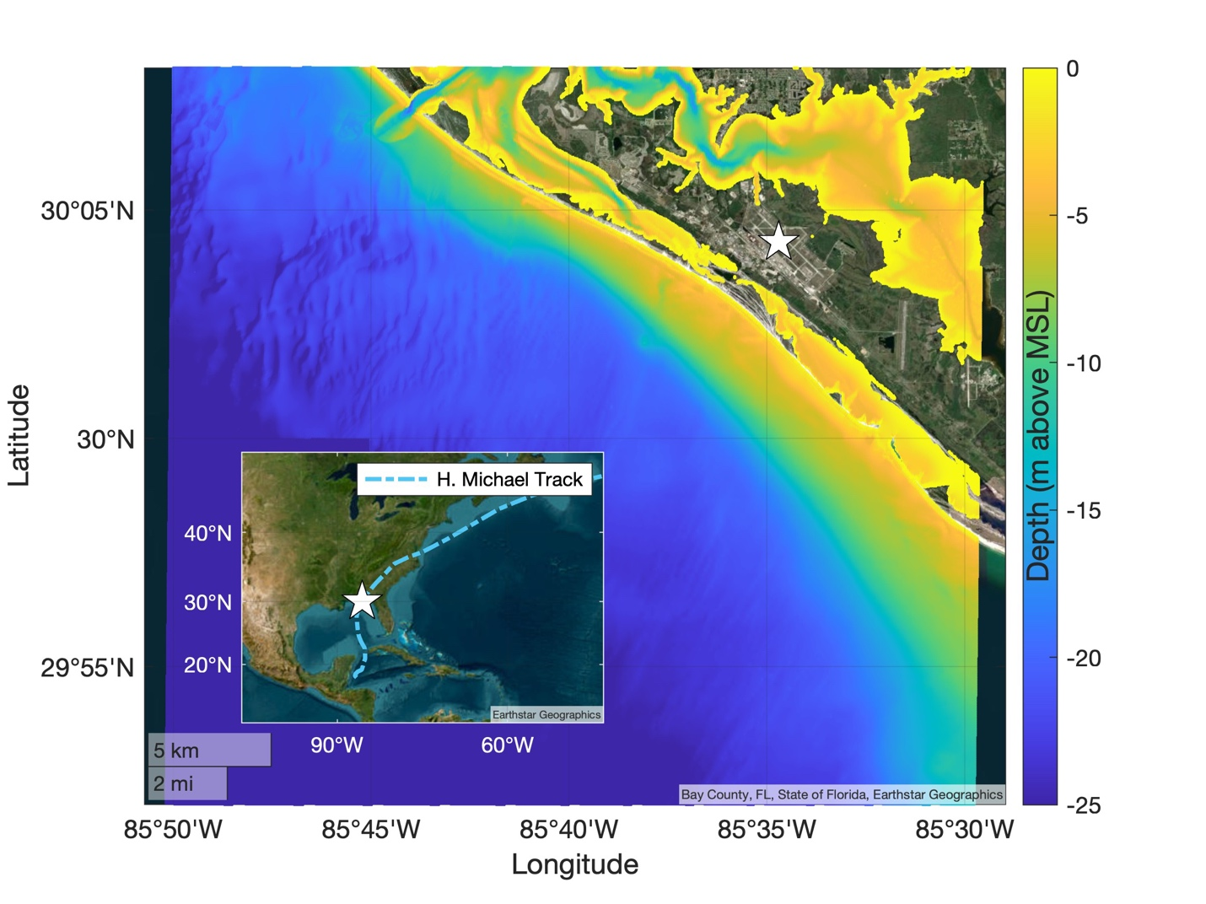

Figure 13. Satellite imagery of Tyndall overlain by color-coded bathymetry showing the wide continental shelf with relatively shallow depths. Inset shows the study site location (star marker, for reference between the main figure and inset) relative to the wider USA. The track of Hurricane Michael (2018) is shown as the dash-dot curve in the inset.

## 4.3 SITE CHARACTERISTICS

Tyndall is separated from the Gulf of Mexico by a semi-connected barrier island, a unique geological feature of this site. The base is also uniquely situated among three bays located on its north (East Bay) and south (Saint Andrew Sound and Saint Andrew Bay) sides. The area has a mean tidal range of 0.38 m and typically experiences waves from the south-southeast with an east-south-easterly wind-wave climate with significant wave heights of 0.4 m and typical peak periods of 5 s (averaged over data from 2006 to 2021). The coastline is characterized by average beach and surf zone (wave breaking region) slopes of 1:20 and 1:30, respectively; where the beach is defined as the region ±2σ around the mean shoreline elevation (setup), σ is the standard deviation of the continuous water level record, and the surf zone is defined as the area between the setup location and the location of wave breaking.

## 4.4 SITE-RELATED PERMITS AND REGULATIONS

No permits are required as this demonstration is a numerical modeling demonstration plan.

# 5.0 TEST DESIGN

## 5.1 CONCEPTUAL TEST DESIGN

The demonstration plan will be conducted along three thrusts:

1) Hurricane Michael simulations: We will conduct initial simulations using the Class II and Class III numerical models for Hurricane Michael actual conditions. These simulations will be referred to as baseline simulations for comparison to subsequent simulations and serve as the output for model calibration / validation. We will then perturb Hurricane Michael forcing to determine the effect of altering forcing parameters. For example, we will modify SLR, central pressure, hurricane track (Figure 14), windspeed, and allow for morphodynamics when possible.

2) Conduct hurricane alteration and model degradation simulations: Degradation studies are needed to infer the output accuracy/fidelity when imperfect initial and boundary conditions are provided. Altered inputs of bathymetric resolution, bathymetric accuracy, National Hurricane Center (NHC) track error, radius of maximum winds (RMW), and overall wind field magnitude (Table 4) will be used.

Alterations and degradations (Table 4) consist of:

1. Coarsening the model bathymetry resolution by factors of 5 and 10. That is, a baseline simulation that may have a grid size of 100 m, would be degraded to 500 m and 1000 m, respectively.
2. Bathymetric accuracy for the elevation data included in the DEMs are 0.3 m (CoNED Topobathy DEM; <https://coast.noaa.gov/dataviewer/#/lidar/search/where:ID=8656/details/8656>); 0.5 m (CUDEM; <https://coast.noaa.gov/dataviewer/#/lidar/search/where:ID=8483/details/8483>); 1 m (NCEI Coastal Relief Model; <https://www.ncei.noaa.gov/products/coastal-relief-model>); and unknown (GEBCO; <https://www.gebco.net/data_and_products/gridded_bathymetry_data/>). Each dataset also has varied horizontal resolution: 1 m, 3 m, 90 m, 450 m respectively. We choose vertical elevation degradations commensurate with the stated vertical accuracy of the data sets: +/- 0.5 m and +/- 1 m.
3. NHC track errors are provided based on the forecast guidance at 36, 72, and 96 hours. The corresponding track errors are 50-55 nm (93-102 km), 90-100 nm (167-185 km), and 130-140 nm (241-259 km). Simulations will use a track shifted above or below the actual track using the mean of each error range.
4. Radius of maximum winds (RMW) are one descriptor of storm “size”. RMW will be varied by a decrease of 10% and increases of 10% and 25%.

E) Wind field magnitude represents the strength of the vector resultant wind velocity at each grid point. Magnitudes will be varied by increasing the wind speed (WS) by 7.5%, 15%, and 22.5%.

F) Central pressure drop (PD) deficit is expected to increase by 8% for every 1° C increase in sea surface temperature (Knutson and Tuleya, 2004; Mousavi et al., 2011). Hence, a central pressure deficit will be increased by 12%, 24% and 36% corresponding to sea surface temperature potential increase of 1.5° C, 3° C and 4.5° C, respectively.

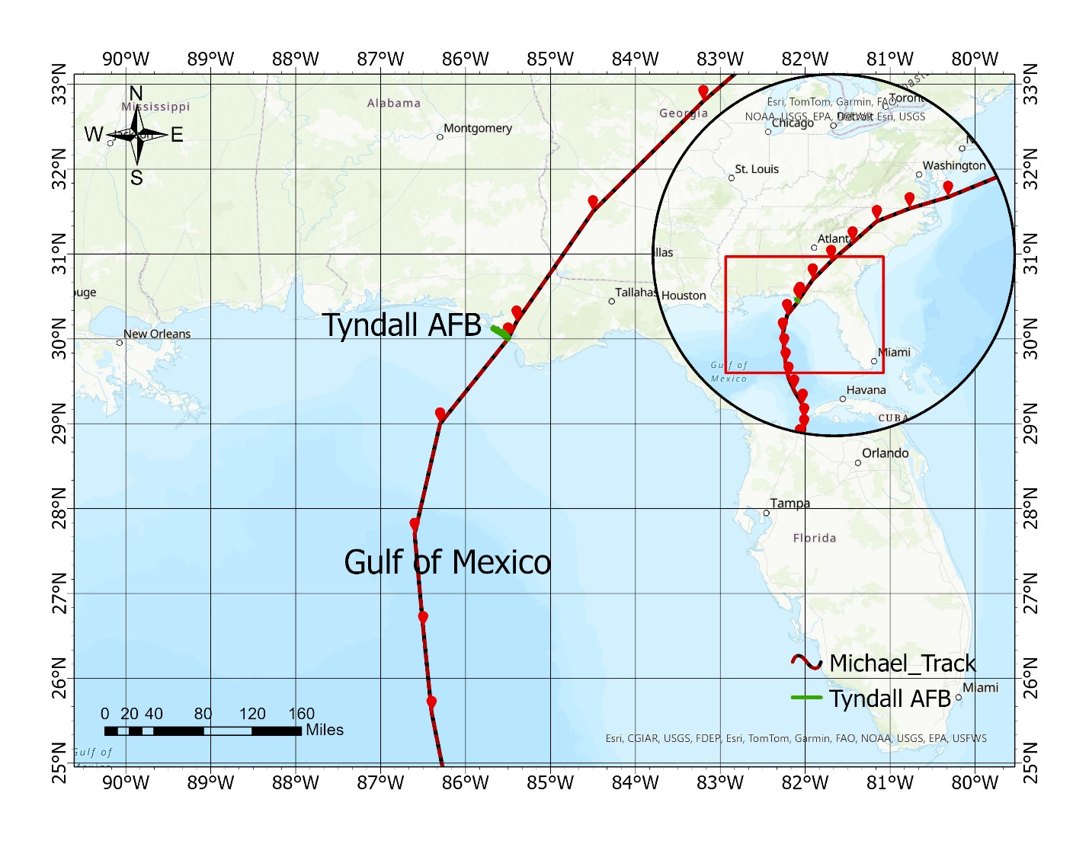

Figure 14. Hurricane track used for the demonstration.

Table 4. Degradations applied to the different model simulations.

|  |  |  |  |  |
| --- | --- | --- | --- | --- |
| **Parameter** | **Alteration 1** | | **Alteration 2** | |
| **Model bathymetry resolution** | Degrade by a factor of 5 | | Degrade by a factor of 10 | |
| **Bathymetry accuracy** | Add gaussian noise of +/- 0.5 m | | Add gaussian noise of +/- 1 m | |
| **Parameter** | **Alteration 1** | **Alteration 2** | | **Alteration 3** |
| **NHC track errors** | 50-55 nm (36 hour forecast) | 90-100 nm (72 hr forecast) | | 130-140 nm (96 hour forecast) |
| **Radius maximum winds (RMW)** | Decrease by 10% | Increase by 10% | | Increase by 25% |
| **Wind field magnitude** | Increase by 7.5% | Increase by 15% | | Increase by 22.5% |

3) Investigate parameterized vs modeled wind/pressure fields: The major forcing mechanism in the Class II models is the wind/pressure field. The entire wind/pressure field can be obtained in a hindcast mode using model validated wind fields via European Centre for Medium-Range Weather Forecasts (ECMWF) Re-analysis v5 (ERA5) *after* the event has occurred. ERA5 also provides predicted wind fields at hourly intervals. A second forcing option relies on a parameterized wind field that contains only the hurricane wind field forcing; referred to as the Holland model (HM; Holland, 1980). There are tradeoffs to using the Holland model vs the ERA5 model (Table 5) and this demonstration provides an opportunity to quantify the varied model output depending on the most widely used forcing approaches.

Table 5. Strengths and weaknesses of the ERA5 and Holland model approaches.

|  |  |  |
| --- | --- | --- |
|  | **ERA5** | **Holland Model (HM)** |
| **Strength** | * Better representation of complexities of the wind field * Reanalysis products include data assimilation * Accounts for background wind/pressures (those not generated by the storm) * Routine predictions available hourly | * Definitely available in real-time * Good accuracy relative to cost * Can develop fields at resolution of mesh and model time step * Can perturb inputs |
| **Weakness** | * Relatively coarse resolution in space (0.25 degrees) and time (hourly) * Difficult to perturb in a physical way, especially the track (due to land masking) * Need to adjust wind/pressure field to focus at storm and blend to background meteorology | * Less accurate than a physics-based model product, no data assimilation |

## 5.2 BASELINE CHARACTERIZATION AND PREPARATION

The total water levels at Tyndall will first be quantified in a baseline characterization using simulations from ADCIRC, Delft3D FM, and NearCom for Hurricane Michael (2018). These simulations will represent the best-possible predictions of storm-driven waves, surge, and coastal flooding during this event and tailored for the installation. These simulations require several inputs to describe the coastal region and the storm:

***Grids***: The coastal region is discretized into a grid (or mesh) with a finite number of computational points, where the models solve for water levels and current velocities. Grid resolution varies to emphasize accuracy near the coast and near critical infrastructure like Tyndall. These grids are developed from DEMs and other datasets that describe the ground surface and characteristics of the coastal region.

ADCIRC: The finite element meshes used in the ADCIRC simulations will be developed using OceanMesh2D, which requires DEMs, land cover data, coastlines, and floodplain boundaries as inputs. The meshes will cover the Atlantic Ocean basin using three DEMs at different resolutions, starting from the 2014 Continuously Updated Digital Elevation Model (CUDEM) and then with higher resolutions from CoNED and other regional DEMs to be identified in the demonstration. Some of the DEM pre-processing will include clipping the set of raster tiles provided by NOAA Data Access, changing the resolution of the clipped tiles, merging the tiles into one raster dataset, converting the coordinate system to WGS84 for compatibility with OceanMesh2D, filling null values by interpolating the neighboring cells and converting the output to a netCDF format. The 2016 Coastal Change Analysis Program (CCAP) Regional Land Cover and Change dataset will be used for the land cover and land use for the Florida panhandle region at 30-m resolution. The CONUS polygon will be used for the global coastline with modifications on the Florida coast to remove barrier islands outside of the Florida panhandle region. The 10-m floodplain line will be used for the global floodplain with modification to include only flooding in the Florida panhandle region.

To develop a mesh that scales in resolution from Tyndall into the Atlantic Ocean, the mesh will be built using three stages with a minimum resolution of 10 m, 50 m, and 1 km at the location-specific, regional, and full-domain scales, respectively. In these regions, the resolutions are controlled using the grades of the scale and the maximum resolution. Although a minimum resolution is given for each stage, the maximum resolution will also be given nearshore. The maximum resolutions will be 50 m, 1 km, and 30 km, respectively. The resolution will be controlled from the coastlines and scales outward to the limits of the DEM over each vertex in the mesh at a grade of 0.2. Nodal attributes, which are constant in time but vary spatially, will be assigned to vertices in the mesh to perform calculations as tides, wind, and wave forcing are applied to the simulation. These nodal attributes include the Manning’s *n*, surface directional effective roughness length, canopy coefficient, and primitive weighting factor, which will be assigned from the land use and land cover dataset.

Delft3D: For Delft3D FM, the coupled (D-Flow FM/D-Wave) model domain spanned 850 km (West to East) x 370 km (North to South). D-Flow FM was set up using a single unstructured grid with a stepwise internal refinement by a factor of 2. In this way, the grid resolution varies from 8 km at the most offshore point to 250 m at Tyndall. D-Wave, on the other hand, was set up using a series of nested structured grids, with resolutions of 5 km, 1 km, and 200 m (at Tyndall). Bathymetric and topographic data were obtained using the Delft Dashboard application (https://publicwiki.deltares.nl/display/DDB/Delft+Dashboard), which merges global (e.g., GEBCO (<https://www.gebco.net/>) and local datasets (e.g., the National Centers for Environmental Information (NCEI) Coastal Relief Model ([CRM](https://www.ncei.noaa.gov/products/coastal-relief-model)) and the National Oceanographic and Atmospheric Administration’s (NOAA) [CUDEM](https://coast.noaa.gov/htdata/raster2/elevation/NCEI_ninth_Topobathy_2014_8483/)). The datasets were merged and interpolated onto the model grids using the tools within the Delft3D FM integrated modeling suite.

NearCom: NearCom uses a structured curvilinear grid based on the Cartesian coordinate. Since the generalized curvilinear grids can be non-orthogonal, they can be generated using either an orthogonal grid generator or a general grid generator. In this study, we use CoastGrid, a MATLAB-based tool with a user-friendly GUI, developed by the University of Delaware. For the Tyndall application, a stretched grid with the finest grid resolution of meters is applied.

CSHORE: CSHORE simulations are run in 1-D mode over individual cross-shore transects. About 70 transects with 1-km spacing are setup covering the coastal area around TAFB ranging from Mexico Beach, FL to Laguna Beach, FL. Depending on location, transects cover between 10 – 15 km in cross-shore distance extending approximately from the 20-m depth contour to the landward boundary beyond the dune line. The offshore model boundary was chosen to coincide with ADCIRC model output locations. Uniform grid spacing of 10, 5, and 1 m is used in separate CSHORE runs. Elevation data were created by blending the 2010 10-m resolution bathy/topo DEM with the 2017 Coastal Lidar DEM sourced from the NOAA Data Access Viewer (https://www.coast.noaa.gov/dataviewer/#/).

XBeach-SB: For XBeach-SB, the model domain spanned 6.0 x 3.4 km, with highest resolution grid spacing set to 2 m on land and in nearshore regions and lowest resolution set to 30 m in offshore regions. The model domain is divided into an “east grid” and a “west grid”, both using the same model resolution as the domain. The east grid spans 3.5 km x 3.4 km with its landward boundary falling in Saint Andrew Bay. The west grid spans 3.5 km x 3.4 km with its landward boundary falling in Saint Andrew Sound. The offshore boundary for each grid is 21 m, depth-matched to the depth from which waves were extracted in the Class II model. Pre-Michael lidar data with 1 m resolution are used for the topography and DEM data with approximately 30 m resolution are used for bathymetry. A spatially varying Manning coefficient is used to represent changes in land cover within the domain. All datasets are downloaded from [NOAA’s Data Access Viewer](https://www.coast.noaa.gov/dataviewer/#/).

***Tides and Waves***: Tides are forced at the offshore boundaries of the grids, and can also be forced internally for a large-domain simulation. These forcings are prescribed in terms of the tidal harmonic constituents; by specifying the amplitudes and phases of the dominant constituents, the overall tide signal can be reconstructed at points along the boundary and internally.

ADCIRC: For ADCIRC simulations, tides are first prepared by forcing at the boundary vertices of the mesh. For the meshes used in the simulation, the boundary resolution ranges between 10 km to 30 km in the Atlantic Ocean just west of the 50-degree line of longitude connecting Nova Scotia in Canada to Paramaribo, Suriname in South America. The database for the tidal simulation uses the major 8 tidal constituents (K1, O1, Q1, P1, M2, N2, K2, and S2) from the TPXO global model for barotropic tide database (Egbert and Erofeeva, 2002). Forcing for the same eight constituents is also used to calculate the tidal force on the internal vertices of the mesh. Typically, the tidal simulation is set up prior to the wind simulation to establish the tide forcing on the grid before the winds are applied. For Hurricane Michael, a 14-day period prior to the storm will be used. The tides simulation is ramped during its first 10 days and then continued for an additional 4 days to achieve a dynamic equilibrium before atmospheric forcing is applied.

Delft3D: Like ADCIRC, the tide is specified in D-FLOW FM along the open boundaries using the tidal constituents (MN4, MS4, M4, MM, MF, K1, O1, Q1, P1, M2, N2, K2, and S2) from the TPXO global model for barotropic tide database. The database is downloaded using the Delft Dashboard application.

NearCom: NearCom addresses the nearshore processes only and thus the computational domain is smaller than that used for D-Flow FM or ADCIRC in a typical tide-surge simulation. The tidal and surge boundary conditions for NearCom are provided by the large-scale model, D-Flow FM. The data format for the boundary conditions is (time, elevation, <velocity>), where <velocity> represents depth-averaged current velocity components and is optional.

CSHORE: CSHORE input water levels at the offshore model boundary (approximately 20-m depth contour) for each transect will be taken from ADCIRC model output data (Class II model) and updated in 20-min increments. The total duration modeled will be roughly 70 hours including the impact of Hurricane Michael. Wave data (*Hrms*, *Tp*) input at the CSHORE offshore boundary for each transect will be obtained from the closest Wave Information Study (WIS) hindcast station (ST73189) for initial runs and then from ADCIRC / SWAN outputs (Bilskie et al., 2022, and our team) for more refined runs.

XBeach-SB: We will simulate Hurricane Michael as a 39-hour storm with storm tides extracted from a Class II model and forced as hourly inputs. Water levels will be extracted at a save point in the Gulf of Mexico to force water levels at the offshore boundary, Saint Andrew Bay to force water levels on the east landward boundary, and Saint Andrew Sound to force water levels on the west landward boundary. Similarly, significant wave height, peak period, and mean wave direction will be extracted from the Class II model at a save point in 21 m depth. These wave characteristics will be forced hourly at the offshore boundary and assumed as a Jonswap spectrum.

***Atmospheric Forcing*:** During simulations, the coastal ocean is driven by atmospheric forcing in the form of surface pressures and wind stresses. These forcings can be obtained from a variety of sources, ranging from simplistic (e.g. models that use a few storm parameters to develop relatively smooth fields for surface pressures and winds) to complex (e.g. models that represent the full physics of the meteorology). In this demonstration, we will mostly use parametric models (based originally on Holland; 1980; Figure 15) because they can represent the storms with an acceptable level of accuracy, and because they will allow for perturbations (to storm track, to storm intensity, etc.) in later stages of the demonstration. Each model (ADCIRC, Delft3D FM) uses a slightly different form of this parametric model.



Figure 15. Hurricane Michael (2018) shown by the wind fields of the Holland model, with panels for (left) about 4 hr before landfall, (center) at landfall, and (right) about 4 hr after landfall. Vectors and contours are wind velocities (m/s) as computed by GAHM/ADCIRC.

We will undertake additional tests using the ERA5 reanalysis dataset provided by the European ECMWF. The reanalysis dataset combines model data with observations from across the world into a globally complete and consistent dataset using the laws of physics. The approach is based on data assimilation where model forecasts/hindcasts are combined with observations to produce a new best estimate. The strengths and weaknesses of this approach, compared to the Holland parametric model, are outlined in Table 6.

ADCIRC: A parametric model based on Holland (1980) is embedded within ADCIRC, so that the atmospheric forcing can be developed from just a few storm parameters. The Holland model has been used and extended for forecasting during several recent storms (Forbes et al., 2010; Mattocks and Forbes, 2008), including a different radial profile in each storm quadrant to improve the representation of storm asymmetry (Xie et al., 2006). Hu et al. (2012) improved on the Holland model formulation by removing the cyclostrophic balance assumption and by introducing a piecewise continuous radial wind profile that matched multiple specified wind isotachs in each quadrant of the storm. However, they used only a single scaling parameter in the pressure profile and were limited to satisfying only $V=V_{max}$ at $r=R_{max}$. Thus, their formulation does not force an actual maximum in the radial wind profile at $V=V_{max}$.

ADCIRC was extended to use a generalized asymmetric Holland model (GAHM; Gao et al., 2017), which includes the previous improvements (Hu et al., 2015, 2012; Xie et al., 2006), but reintroduces the two scaling parameters from the original Holland formulation, satisfying both $V=V_{max}$ and $dV/dr=0$ at $r=R_{max}$ without assuming a cyclostrophic balance at $r=R_{max}$. The cyclostrophic balance is violated by large and weak storms, which is often typical of storms as they approach landfall (Gao et al., 2017; Hu et al., 2012). GAHM is a better representation of the storm described in the parameters, e.g. the best-track and forecast advisories from the National Hurricane Center.

GAHM is implemented within ADCIRC, so the surface pressure and wind fields can be determined dynamically at every point in the computational domain. For the demonstration simulations, we use the best-track analyses provided by the National Hurricane Center; these analyses describe the storm at most every 6 hours and provide parameters about the track, size, intensity, and isotachs in the storm quadrants.

Delft3D FM: Hurricane winds and pressure can be specified in D-FLOW FM using two methods:

1.      The wind and pressure fields that vary in both space and time are specified using a curvilinear grid.

2.      A cyclone wind/pressure field is prescribed on a polar grid with the center (‘eye’) of the hurricane being the origin of the polar coordinate system. The location of the eye, and the corresponding wind/pressure field, is allowed to vary in time.

With the above methods in mind, two different approaches for atmospheric forcing were considered for the demonstration. Using method 1, the ERA5 hindcast winds and pressures were specified on a regular grid and used as model input. For comparison, the D-Flow FM/D-Wave model was also set up with parametric wind and pressure forcing (method 2) instead of the ERA5 dataset. This approach was achieved in a manner like ADCIRC using the Holland et al. (2010) model and supporting relations (Holland, 2008; Nederhoff et al., 2019) to replicate wind and pressure generated by Hurricane Michael (2018). The polar grid was generated using the Delft Dashboard application. Similar approaches will be used for the other events of the demonstration.

NearCom: The original Holland model (Holland, 1980) was implemented in NearCom to model wind/pressure forcing in storm surge simulations. The model also has an optional wind/pressure input which can come from a large-scale model. In NearCom applications for storm events, the wind/pressure data are provided by a large-scale model, consistent with the boundary conditions from the same large-scale model.

CSHORE: CSHORE has the option to add wind forcing by specifying a representative 10-m elevation wind speed and direction for the entire transect at each time step. Wind will be included in the CSHORE simulations.

## 5.3 DESIGN AND LAYOUT OF TECHNOLOGY AND METHODOLOGY COMPONENTS

### 5.3.1 Baseline simulations

Baseline simulations are those using the known hurricane parameters as obtained from ERA5 reanalysis or statistics fed into the Holland model. The baseline conditions generally serve for validation/calibration purposes and as the comparator for forcing and degradation modifications.

### 5.3.2 Hurricane Michael: Parameter Alteration

A thorough parametric effort will be undertaken to determine the response at Tyndall to altering relevant parameters for Hurricane Michael. The baseline simulation will be altered for:

A) SLR. Mean sea level in each model will be modified following Sweet et al. (2022) for “Intermediate-Low” scenarios for the US East Coast: 0.4 m, 0.8 m, 1.3 m, projected for years 2050, 2100 and 2150.

B) Central Pressure Drop. The central pressure will be modified following Mousavi et al. (2011) for sea surface temperature increases of 1.5° and 3° C; leading to central pressure drops of 12%, and 24%, respectively.

C) Hurricane Track. Track changes following Salehi (2018) using multiples of the radius of maximum winds; here 55 NM either side of the present track.

D) Wind Speed. Wind will be modified using changes following Camelo et al. (2020) and Emanuel (1987) where the speed increases by 5% for every degree increase of sea surface temperature. That is, 7.5%, 15%, and 22.5% respectively for the used sea surface temperature increases.

### 5.3.2 Degradation

Degradation simulations consist of the modifications described in Section 5.1. Only a single parameter is degraded/altered for a particular simulation with a chosen model.

## 5.4 FIELD TESTING

There is no field testing to be conducted as part of this demonstration plan.

## 5.5 SAMPLING PROTOCOL

No team generated field sampling will be conducted. Model data at each grid point and at relevant locations to available field data will be archived from the simulations. The local POC, Lance Marrano (USACE) will help coordinate data availability from other researchers conducting field efforts at Tyndall.

Anecdotal Data and Elevation Models: TWL and onshore flooding information for the wider study area (Laguna Beach to Mexico Beach) are sourced from USGS Flood Event Viewer (USGS, 2018). Around Tyndall AFB, two high water marks are assessed, one as a seed line inside the Officer’s Club, and one as a debris line on a gravel road. At Mexico Beach where the flooding levels were much higher, many high water marks are assessed from seed lines (20+).

Changes in topography and bathymetry are assessed using freely available LiDAR data sourced from NOAA Data Access Viewer. Pre-storm onshore (above 0 m MSL) elevation is assumed as the 2017 Northwest Florida Water Management District (NWFWMD) Lidar DEM: Lower Choctawhatchee Layer, recorded March 5th, 2017, with cell size of 1 m and a non-vegetated vertical accuracy of 0.099 m at 95% confidence interval. Post-storm onshore elevation is assumed as the 2018 USACE FEMA Post-Michael Topo/bathy Lidar DEM: Florida Panhandle Layer, recorded November 6th 2018, with cell size of 1 m and compiled to meet 19.6 cm vertical accuracy at 95% confidence interval. Offshore bathymetry (below 0 m MSL, out to approximately the 20 m depth contour) is assumed as the Continuously Updated Digital Elevation Model (CUDEM) - 1/9 Arc-Second Resolution Bathymetric-Topographic Tiles Layer, with a cell size of 3 m, and an approximate vertical accuracy of 50 cm.

NOAA Buoys & Tide Gauges: In addition to the community reported flood extent, the coupled D-Flow FM/D-Wave model setup will be validated by comparing the modeled waves, and surge to observations at offshore buoys ([National Data Buoy Center](https://www.ndbc.noaa.gov/)) and tide gauges ([NOAA Tides & Currents](https://tidesandcurrents.noaa.gov/stations.html?type=Water+Levels)) during Hurricane Michael (2018).

A Hobo barometric sensor was placed on the Mexico Beach Pier for the duration of the storm, STD Site No. FLBAY03283 (USGS), water levels were recorded every 30 s, with readings near the shoreline at Mexico Beach, approximately 22 km southeast of Tyndall.

Panama City Beach Pier, STD ID 8729210 (NOAA) recorded water levels, air temperature, wind speeds and directions, and air pressure every 6 minutes. Located approximately 28 km northwest from Tyndall.

The closest publicly available measured hydrodynamic data offshore from Tyndall is sourced from a NOAA buoy, STD ID 42039 (NOAA), approximately 183 km from Tyndall. The station is located in 281 m water depth, and recorded water levels, wave heights, air temperatures, wind speeds, and air pressure, at hourly intervals. The station stopped recording on October 8 and so does not provide enough information to cover the duration of the event.

Two other NOAA buoys are also publicly available, STD ID 42012 and STD ID 42040, approximately 200 km and 283 km west and southwest of Tyndall, respectively. The stations are located in a water depth of 23.5 m and 192 m respectively, and recorded data at hourly intervals.

Non-measurement sources: Due to the lack of measured data sources for the event close to the site, other data sources are used as inputs for initial CSHORE and XBeach model runs.

Initial runs use a combination of inputs from USACE ERDC Wave Information Study (WIS) (Hall et al., 2024) and Coastal Emergency Risk Assessment (CERA). WIS provides significant wave height, peak wave period and wave direction time series. CERA provides water level and wind speed timeseries for the duration of the storm event. Both WIS and CERA use wind fields and hindcast models to derive the respective hydrodynamic outputs.

Note: For the second phase of CSHORE runs, hydrodynamic inputs will be sourced from updated ADCIRC model outputs of Hurricane Michael (Bilskie et al., 2022, and our team’s simulations), including wind and wave direction.

## 5.6 MODEL CALIBRATION AND DATA QUALITY ISSUES

### 5.6.1 Calibration of Models

ADCIRC: Model calibration was achieved by using standard practices for inputs for atmospheric forcing and model dissipation. Wind speeds are converted to surface stresses via a drag coefficient *CD*, which varies linearly to wind speeds of about 25 m/s, and then is capped at *CD* = 2.5×10-3 (Dietrich et al., 2011a). Bottom friction is represented with a Manning’s formulation with *n* values assigned from land-use/land-cover data, with no lower limit on the bottom friction coefficient. Horizontal eddy viscosity is specified with a value of 50 m2/s. For model dissipation, ADCIRC uses a weighting factor *τ0* in its modified continuity equation; this factor is also specified with a depth-based scheme with values of 0.03 in shallow waters (resolution finer than 2 km), 0.02 in intermediate waters (depths less than 10 m) and 0.005 in deep waters. These parameter settings are default and have been well-validated in coastal flooding studies with ADCIRC.

Delft3D FM: Model calibration is achieved by adjusting the tidal signal and bed roughness, and by varying the wind $C_{D}$ in D-FLOW FM to minimize the error between the modeled and observed surge during Hurricane Michael (2018), as is often done in practice. $C_{D}$ is set using a piecewise (three-point) linearly varying approach, where $C_{D}$ is allowed to vary with wind speed (*U*): $C_{D}^{A}=0.5×{10}^{-3}$ at $U^{A}=0$ m/s, $C_{D}^{B}=1.0×{10}^{-3}$  at $U^{B}=10$  m/s, and $C_{D}^{C}=4×{10}^{-3}$  at $U^{C}=30$  m/s. The superscripts *A*, *B*, and *C* refer to the three breakpoints based on wind speed. In addition, an offset to the initial water level is used to account for the physical processes (e.g. baroclinic effect) not simulated by the model.

NearCom: NearCom is set up using default values for model parameters in the initial model setup. However, it is necessary to tune those parameters based on applications. Generally, the bottom friction coefficient, *CD*, can be adjusted in a range of 0.001 ~ 0.003 (Chezy formula). The minimum depth used for modeling wetting and drying (inundation) can be set to 0.01 – 0.05 m for field applications. For modeling sediment transport and morphological changes, several parameters can be adjusted, including the median grain size, porosity, and critical Shields stress.

CSHORE: CSHORE is initially set up using recommended values for model parameters. Grain size (D50), sediment fall velocity (WF), and sediment specific gravity (SG) are updated to match local sediment conditions. The PONDED subroutine (IPOND) which computes onshore ridge and runnel migration is turned off to avoid modeling issues caused with high water levels and complexity of the onshore bathymetry. Wind and wave direction inputs are converted to be in line with each profile, with a limit of 30° on either side of the profile to prevent model crashes. Any wind or wave directions going against the profile (> 90°) are zeroed for the given timestep. Complex offshore bathymetry is smoothed, and the profile is extended landward with an artificial wall beyond the region of interest to prevent modeling disconnects at high water levels.

Calibration of CSHORE results is done using Mexico Beach, FL, high water marks recorded by USGS and estimated flooding levels at the beach fronting TAFB. Calibration is accomplished via sensitivity analysis (+/- 20% of recommended) of CSHORE parameters related to hydrodynamics and sediment transport as well as turning on/off various optional subroutines related to vegetation, surf zone roller dissipation, and wind effects.

XBeach-SB: Model calibration will be achieved by adjusting the bed roughness and specifying a median grain size representative of beaches near Tyndall Air Force Base. The bed roughness will be specified as spatially varying Manning roughness coefficients representative of land cover characteristics. The median grain size will be set to 0.225 mm to represent fine sand.

### 5.6.2 Quality Assurance Sampling

No field data will be collected as part of this demonstration plan. Validation data will be obtained from online data sources and anecdotal records.

### 5.6.3 Sample Documentation

No field data will be collected as part of this demonstration plan. Individual researchers will maintain spreadsheet records of the model simulation being conducted, the clock time required to prepare the model, the model simulation duration, the clock time required to complete the simulation, and the architecture used to complete the simulation.

# 6.0 PERFORMANCE ASSESSMENT

## 6.1 General Statistical Analyses

Model accuracy in predicting the magnitude and timing of peak water level (or other parameters) will be evaluated using a variety of statistical metrics:

|  |  |  |  |
| --- | --- | --- | --- |
| |  |  | | --- | --- | | Root mean square error: | $RMSE=\sqrt{\frac{1}{n}\sum_{i=1}^{N}{{\left(ψ_{modeled}^{i}-ψ_{observed}^{i}\right)}^{2}}}$, | | 1 |

|  |  |  |  |
| --- | --- | --- | --- |
| |  |  | | --- | --- | | Bias | $$Bias= \sum_{i=1}^{N}{\frac{1}{N}\left(ψ_{modeled}^{i}-ψ_{observed}^{i}\right) }$$ | | 2 |

|  |  |  |  |
| --- | --- | --- | --- |
| |  |  | | --- | --- | | Coefficient of determination | $R^{2}=1-\frac{\sum_{i=1}^{N}{{\left(ψ_{modeled}^{i}-ψ_{observed}^{i}\right)}^{2}}}{\sum_{i=1}^{N}{{\left(ψ_{modeled}^{i}-\overline{ψ_{observed}^{i}}\right)}^{2}}}$, | | 3 |

where $ψ$ represents the parameter being assessed at some station *i*. Increases in RMSE indicate reduced model accuracy. Positive or negative bias indicate over- and under-predictions, respectively, by the model. These parameters enable investigation of the overall magnitude differences between predictions and observations. The coefficient of determination and corresponding best fit slope quantify how much the predictions varied from the observations, thereby giving an indication of how well the simulations performed (e.g. a perfect fit would have a slope of unity).

## 6.2 Specific Approaches for Each Objective

Objective 1: Each user will document carefully the personnel time required to prepare a model simulation. These times will be tested against those in the performance matrix using a simple differencing algorithm.

Objective 2: Each user will document carefully the computational run time required to conduct a model simulation. These times will be tested against those in the performance matrix using a simple differencing algorithm.

Objective 3: Data from available stations will be queried for the time of peak surge. Model output interpolated to the station location will also be queried for the time of peak surge. A simple difference algorithm will be used to quantify the skill in predicting peak surge timing (Figure 16).

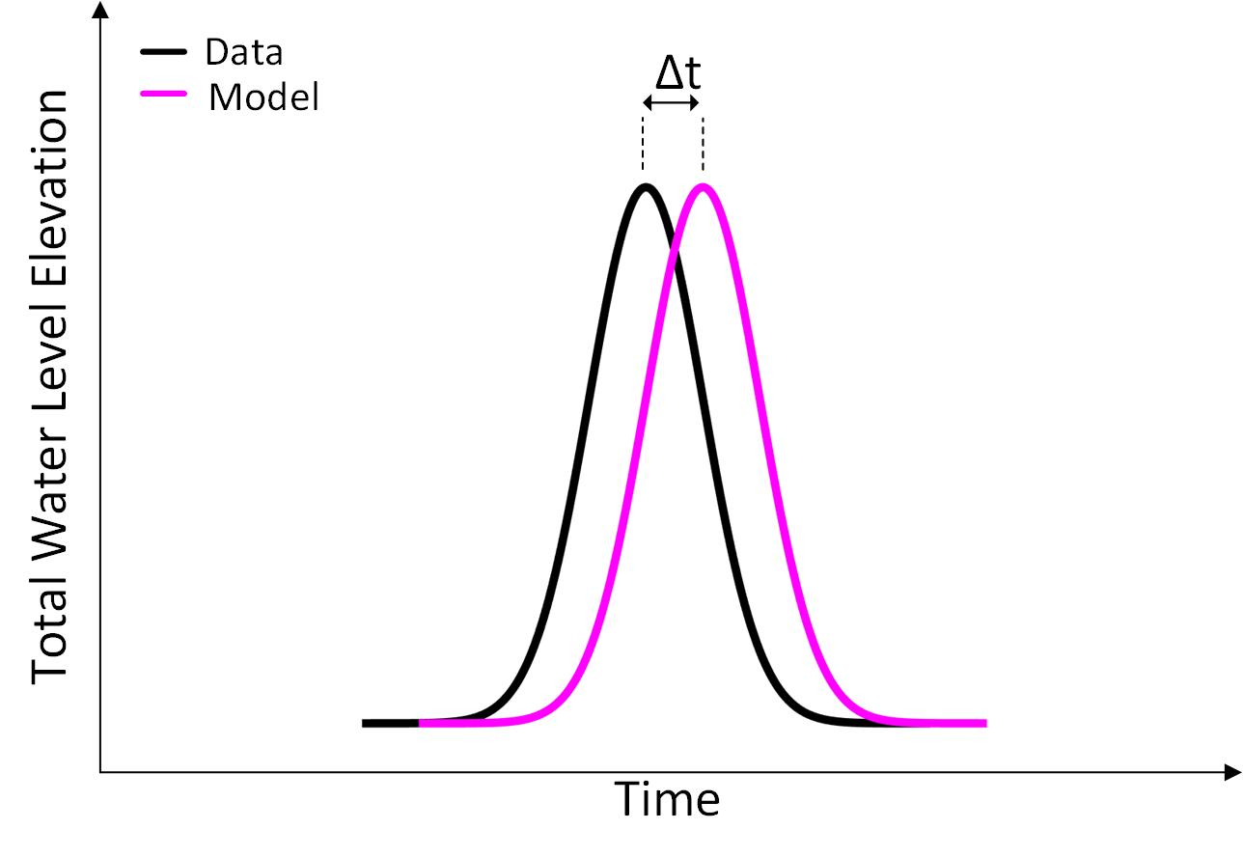

Figure 16. Schematic showing estimate of the timing of model predicted and actual peak surge (Total Water Level Elevation).

Objective 4: Data from available stations will be queried for the magnitude of peak surge. Model output interpolated to the station location will also be queried for the magnitude of peak surge. A simple difference algorithm will be used to quantify the skill in predicting peak surge magnitude (Figure 17).

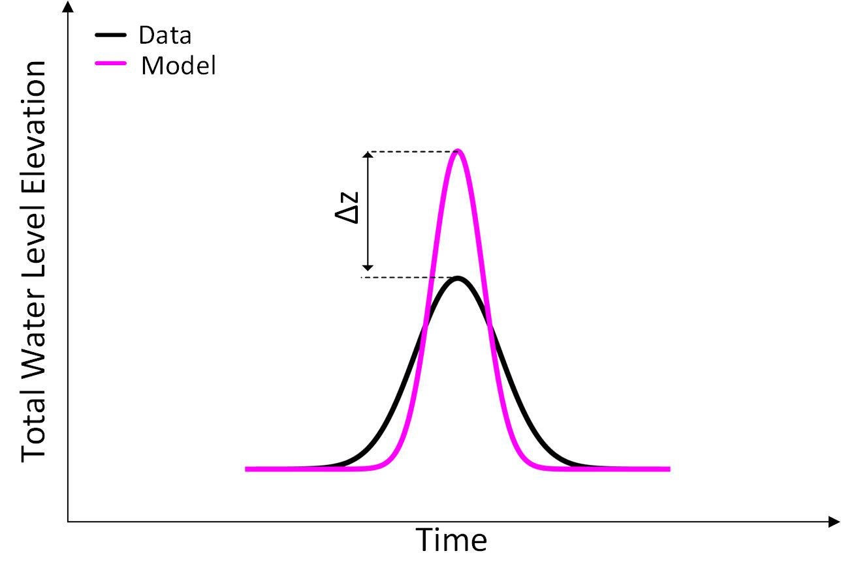

Figure 17. Schematic showing estimate of the maximum amplitude of model predicted and actual peak surge (Total Water Level Elevation).

Objective 5: A range of flooding levels will be selected. Data from available stations will be queried for the start and end time that each flooding level was exceeded. Model output interpolated to the station location will also be queried for the start and end time that each flooding level was exceeded. The difference between start and end time for the data or model output yields the flooding duration at a particular flooding level. A simple difference algorithm will be used to quantify the skill in predicting flooding duration at each flooding level (Figure 18).

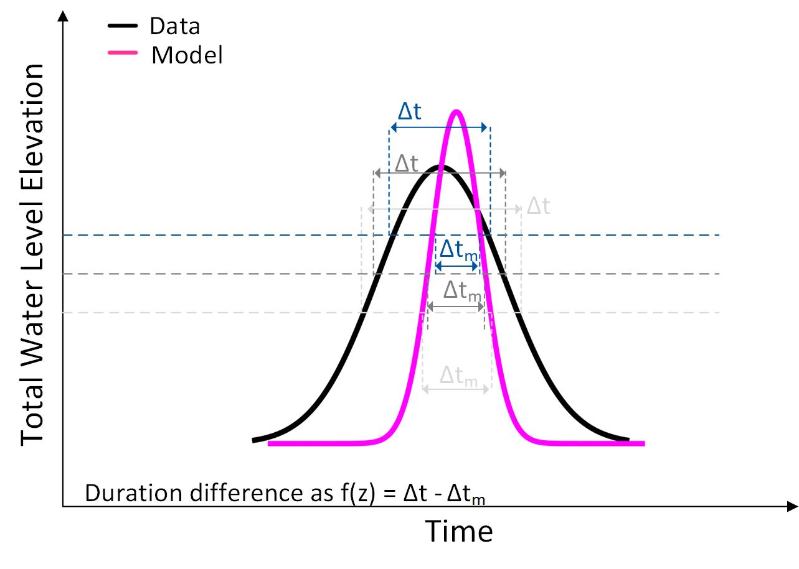

Figure 18. Schematic showing estimate of the duration of model predicted and actual flooding as a function of Total Water Level Elevation cutoff.

Objective 6: We will identify flooded spatial area as a function of time and flooded depth and compare the results, where possible, to available anecdotal data. Actual flood elevations will be determined after conducting the simulation. Subsequently, flooded area will be quantified for each flood elevation level.

Objective 7: We will conduct alteration and degradation simulations to the base model simulation to quantify prediction error when there is a deficit of information (resolution and/or accuracy). There is no performance metric. However, these simulations provide critical information on prediction confidence when input and forcing data are imperfect (always the case in a predictive scenario). Model to model comparison will be conducted using the relevant aforementioned parameters.

Objective 8: Model simulation results will be archived in long-term storage systems with hyperlinks provided on a webpage for program manager review. User-interactive graphic views of model results will be generated using web-friendly interactive mapping techniques, such as the LEAFLET program (Figure 19; example from the Naval Station Norfolk demonstration). Automated programs suitable for multiple computer platforms will be used to transfer data between computational resources and storage systems. The qualitative metric is related to ease of use and ability for technical-level personnel to understand and use the data in a decision-making process.

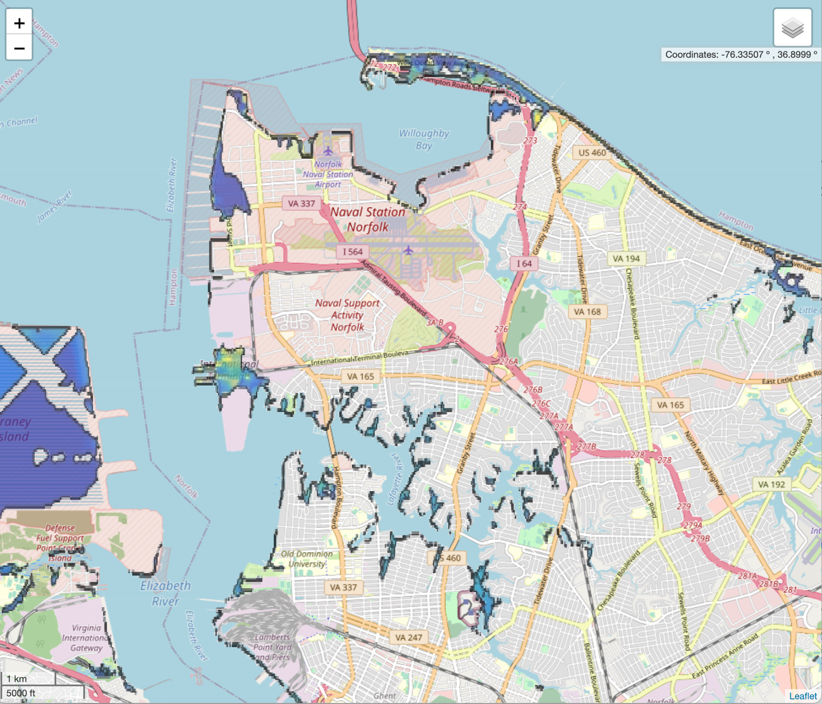

Figure 19. Example snip from the webpage showing flooded area for a storm event for the prior demonstration at Naval Station Norfolk (The webpage shell for Tyndall has not yet been developed).

# 7.0 COST ASSESSMENT

In this demonstration, the technologies used are empirical and numerical models for predicting TWL at military installations. We aim to minimize costs associated with model set up and execution. We indicate from the outset that identifying exact costs are inexact. We will produce what we believe are realistic estimates described in the following categories and Table 6.

*Model Software*: All models in this demonstration are available freely from their developers. ADCIRC is shared freely with academic and government researchers <https://adcirc.org>, and it is used by DoD staff at the USACE and elsewhere. Delft3D FM is open source and available upon request from Deltares (<https://oss.deltares.nl/web/delft3dfm/get-started>). A precompiled version with graphical user interface (2023.02 release) was provided free of charge for this study under an academic license. NearCom is open-source software developed by CACR and is available at the Github repository: <https://github.com/fengyanshi/NEARCOM-TVD>. CSHORE is open source software. The USACE maintains a version for download on GitHub (https://github.com/erdc/cshore/tree/master) and the most recent “research” version of the code including the latest additions is available free of charge by contacting the developer team at CACR ([nk@udel.edu](mailto:nk@udel.edu)). XBeach-SB is open-source software developed by Deltares and is available as source code or precompiled executables at <https://oss.deltares.nl/web/xbeach/release-and-source>. As such, we treat the cost associated with these computational tools as $0.

*Input Data*: As described earlier, numerical models require data about the coastal environment (configuration of coastline, bathymetry/topography, land-use/land-cover, etc.) and the storm of interest (track, size, intensity, etc.). These data can be obtained freely from public databases. For ground surface elevations and land-cover data, DEMs and geoTIFFs can be obtained from NOAA Digital Coast (<https://coast.noaa.gov/digitalcoast/>). For storm parameters, forecast consensus and hindcast best-track information can be obtained from the National Hurricane Center (<https://www.nhc.noaa.gov>) to develop parametric models, and prediction and reanalysis products can be obtained from ECWMF (<https://www.ecmwf.int/en/forecasts/dataset/ecmwf-reanalysis-v5>) for the ERA5. These data sets are updated regularly by their relevant agencies, and there may also be additional data for other military installations available to DoD staff. Collecting our own data from sensor installation has a significant cost, but was not feasible for the demonstration at Tyndall. Thus, for the demonstration at Tyndall, we will treat data costs as $0 excluding personnel time to retrieve the data which is included in the model setup time computation.

*Computational Resources*: Another key cost is access to computing resources to run each model simulation. Only empirical simulations for this demonstration are reasonable to run on a desktop computer, all other simulations are feasible only on parallel computing clusters. As an example, in this demonstration, ADCIRC simulations will be run typically on 128 or 256 CPUs at the high-performance computing center at North Carolina State University, with additional simulations on a national cluster at Purdue University via the NSF ACCESS program. Delft3D FM and NearCom simulations are run typically on a NSF-supported University of Delaware high performance computer (HPC) called DARWIN. Simulation using Delft3D FM can take roughly 12 hours on 10 CPUs. NearCom simulations can take approximately 5 hours on 64 CPUs. CSHORE simulations run on the order of seconds to minutes on a single CPU desktop machine depending on simulation time steps. XBeach-SB simulations require up to 36 hours on a single CPU. Researchers and military personnel may have similar access to clusters locally (at their home institutions) or nationally (via ACCESS and similar programs).

Costs for computing resources can be significant, especially for parallel computing. Local HPC access may exist at universities having been acquired over years of other project support. Typical costs are approximately $20k per core or approximately $325 per CPU; not including additional/ongoing costs for operation and maintenance of computing resources. These costs are likely similar for parallel computing clusters at other institutions and at DoD sites. For this demonstration we estimate the total computational resource “cost” of $250k (a rough estimate for 10 nodes, 640 CPUs, and maintenance). Note, that this is not a recurring cost for each model setup or each simulation.

*Researcher Effort – Model Setup and Simulation*: A major cost for model implementation is the time required for the researcher/user to set up, calibrate, and validate each model at each military installation. As described above, we will track the time requirements as part of this demonstration, with goals for implementation of each model/class. We make a distinction between expert user and non-expert user in terms of personnel costs. Here, an expert is defined as a PhD student, Post Doc or Professor with extensive experience using a particular model. Personnel hourly rates including fringe benefits and facilities and administrative costs are estimated at $64, $103, and $258, respectively. Table 2 indicates the expected time to set up the different types of models. We expect an additional 20 weeks per model type to address the performance objectives and model simulation variations. These time frames are used to generate a cost estimate for this demonstration (Table 6) noting that personnel are devoting only a portion of the work week to this project. It is important to note that future simulations at other installations may or may not require this amount of time as the wide range of variations in model simulation may not be necessary.

For this demonstration, we assume that these researchers are available already (at our home institutions) and do not need to be hired specifically for simulations of coastal flooding at military installations. For adoption by the DoD, simulations could be conducted by DoD staff who are already trained experts in coastal modeling, or offsite contractors with the required expertise. For this demonstration, we will track the person-power requirements (time for model setup, etc.) for each model/class, but we will not attempt to quantify the costs for other personnel conducting the simulations. It is important to note that costs for model setup and simulation efforts for non-model experts will be significantly more than the estimates for the personnel funded on this ESTCP project.

*Researcher Effort – Webpage Development*: Project personnel will manipulate the model output into graphs and data overlain on charts or aerial imagery for project manager perusal. These data products will be displayed on a dedicated web page with menus for selecting different scenarios enabling managers to rapidly infer the effect of altering model parameters. We estimate the expert researcher time to generate the web interface at 40 hours total.

Each researcher will maintain a time spreadsheet that will be collated and recorded to indicate total effort.

Table 6. Cost estimates for Tyndall model simulations.

|  |  |
| --- | --- |
| **Cost Category** | **Cost ($k)** |
| **Model software**: Delft3D, NearCoM, ADCIRC, CSHORE, and XBeach are freely available from internet repositories | 0 |
| **Data products**: Data for model calibration/validation (e.g. water level, waves) are freely available from numerous data sources | 0 |
| **HPC**: We estimate a one-time cost for a cluster consisting of 10 nodes (640 CPUs) to conduct model simulations (noting that the HPC needs for this project were provided by existing University resources) | 250 |
| **Personnel time – model set up**: Total model set up time is estimated at 8 weeks for the 8 personnel involved in the demonstration | 62 |
| **Personnel time – simulations**: Total estimated time to conduct simulations, investigate output, re-run simulations as needed, and produce useable model output is estimated as a total of 20 weeks for the 8 personnel involved in the demonstration | 133 |
| **Personnel time – webpage**: Total estimated time to take useable model output to generate easily understood figures/graphs is estimated at 1 week | 8 |
| **TOTAL** | **453** |

# 8.0 SCHEDULE OF ACTIVITIES

The schedule of activities is presented in a Gantt chart (Figure 20) where gray shades indicate months of expected activity.



Figure 20. Gantt chart of demonstration activities.

# 9.0 MANAGEMENT AND STAFFING

Demonstration plan efforts are distributed across the various researchers on the project as shown in the flow chart (Figure 21). Puleo is responsible for the overall project coordination and empirical estimates. Other researchers are responsible for model simulations using software that they have developed and/or are experts on: Elkut (Delft3D); Shi (NearCom); Dietrich and Knowles (ADCIRC), Figlus and Joshua Joubert (CSHORE), Patch and Quataert (XBeach-SB)



Figure 21. Flow chart showing organization of researchers for the demonstration.

# 10.0 REFERENCES

Beven, J.L., Berg, R., Hagen, A., 2019. National Hurricane Center Tropical Cyclone Report - Hurricane Michael (No. AL142018). NOAA, NHC, Miami, FL.

Bilskie, M., Asher, T., Miller, P., Fleming, J., Hagen, S., Luettich, R.A., 2022. Real-Time Simulated Storm Surge Predictions during Hurricane Michael. Weather and Forecasting 3, 1085–1102.

Blanton, B.O., McGee, J., Fleming, J.G., Kaiser, C., Kasier, H., Lander, H., Luettich, R.A., Dresback, K.M., Kolar, R.L., 2012. Urgent computing of storm surge for North Carolina’s coast. Proceedings of the International Conference on Computational Science 9, 1677–1686.

Booij, N., Ris, R.C., Holthuijsen, L.H., 1999. A third-generation wave model for coastal regions - 1. Model description and validation. Journal of Geophysical Research 104, 7649–7666.

Bunya, S., Dietrich, J.C., Westerink, J.J., Ebersole, B.A., Smith, J.M., Atkinson, J.H., Jensen, R.E., Resio, D.T., Luettich, R.A., Dawson, C.N., Cardone, V.J., Cox, A.T., Powell, M.D., Westerink, H.J., Roberts, H.J., 2010. A high-resolution coupled riverine flow, tide, wind, wind wave and storm surge model for southern Louisiana and Mississippi: Part I Model development and validation. Monthly Weather Review 138, 345–377.

Burks-Copes, K.A., many others, 2014. Risk Quantification for Sustaining Coastal Military Installation Assets and Mission Capabilities (Final Report No. RC-1701). SERDP.

Chen, J., Shi, F., Hsu, T.-J., Kirby, J.T., 2014. NearCoM-TVD - a quasi-3D nearshore circulation and sediment transport model 91, 200–212.

Cheriton, O.M., Storlazzi, C.D., Rosenberger, K.J., 2016. Observations of wave transformation over a fringing coral reef and the importance of low-frequency waves and offshore water levels to runup, overwash, and coastal flooding. Journal of Geophysical Research-Oceans 121, 3121–3140.

Dietrich, J.C., Tanaka, S., Westerink, J., Dawson, C.N., Luettich, R.A., Zijlema, M., Holthuijsen, L.H., Smith, J.M., Westerink, L.G., Westerink, H.J., 2012. Performance of the Unstructured-Mesh, SWAN+ADCIRC Model in Computing Hurricane Waves and Surge. ournal of Scientific Computing 52, 468–497.

Dietrich, J.C., Westerink, J.J., Kennedy, A.B., Smith, J.M., Jensen, R.E., Zijlema, M., Powell, M.D., Cardone, V.J., Cox, A.T., Stone, G.W., Pourtaheri, H., Hope, M.E., Tanaka, S., Westerink, L.G., Westerink, H.J., Cobell, Z., 2011a. Hurricane Gustav (2008) Waves and Storm Surge: Hindcast, Validation and Synoptic Analysis in Southern Louisiana. Monthly Weather Review 139, 2488–2522.

Dietrich, J.C., Zijlema, M., Westerink, J., Holthuijsen, L.H., Dawson, C.N., Luettich, R.A., Jensen, R.E., Smith, J.M., Stelling, G.S., Stone, G.W., 2011b. Modeling Hurricane Waves and Storm Surge using Integrally-Coupled, Scalable Computations. Coastal Engineering 58, 45–65.

DoD, 2014. 2 0 1 4 Climate Change Adaptation Roadmap. Department of Defense, Washington, D.C.

Donoghue, J.F., Elsner, J.B., Hu, B.X., Kish, S.A., Niedoroda, A.W., Wang, Y., Ye, M., 2013. Effects of Near-Term Sea-Level Rise on Coastal Infrastructure (Final Report No. RC-1700). SERDP.

Ebersole, B.A., Westerink, J.J., Resio, D.T., Dean, R.G.., 2007. Performance Evaluation of the New Orleans and Southeast Louisiana Hurricane Protection System, Volume IV - The Storm, Final Report of the Interagency Performance Evaluation Task Force., Volume IV - The Storm, Final Report of the Interagency Performance Evaluation Task Force. U.S. Army Corps of Engineers.

Egbert, G.D., Erofeeva, S.Y., 2002. Efficient inverse modeling of barotropic ocean tides. Journal of Oceanic and Atmospheric Technology 19, 183–204.

FEMA, 2021. Flood Risk Study Engineering Library https://hazards.fema.gov/wps/portal/frisel.

Figlus, J., Kobayashi, N., Grahler, C., Iranzo, V., 2011. Wave Overtopping and Overwash of Dunes. Journal of Waterway, Port, Coastal, and Ocean Engineering 137. https://doi.org/10.1061/(ASCE)WW.1943-5460.0000060

Fleming, J.G., Fulcher, C., Luettich, R.A., Estrade, B., Allen, G., Winer, H., 2007. A real time storm surge forecasting system using ADCIRC. In Estuarine and Coastal Modeling. Estuarine and Coastal Modeling 893–912.

Forbes, C., Luettich, R.A., Mattocks, C., Westerink, J.J., 2010. A retrospective evaluation of the storm surge produced by Hurricane Gustav (2008): Forecast and hindcast results. Weather Forecasting 25, 1577–1602.

Forbes, C., Rhome, J., Mattocks, C., Taylor, A., 2014. Predicting the Storm Surge Threat of Hurricane Sandy with the National Weather Service SLOSH Model. Journal of Marine Science and Engineering 2, 437–476.

GAO, 2019. CLIMATE RESILIENCE: DOD Needs to Assess Risk and Provide Guidance on Use of Climate Projections in Installation Master Plans and Facilities Designs (Report to Congressional Requesters No. GAO-19-453). United States Government Accountability Office, Washington D.C.,.

Gao, J., Luettich, R.A., Fleming, J.G., 2017. Development and evaluation of a generalized asymmetric tropical cyclone vortex model in ADCIRC (ADCIRC Users Group Meeting). U.S. Army Corps of Engineers, Vicksburg, MS.

Glahn, B., Taylor, A., Kurkowski, N., Shaffer, W.A., 2009. The Role of the SLOSH Model in National Weather Service Storm Surge Forecasting. National Weather Digest 33, 3–14.

Hall, C., Jensen, R.E., Collins, C.O., Hesser, T.J., Brown, M.E., 2024. Wave Information Study: 2021 Annual Update (No. ERDC/CHL CHETN-I-xx). U.S. Army Engineer Research and Development Center, Vicksburg, MS.

Hall, J.A., Gill, S., Obeysekera, J., Sweet, W., Knuuti, K., Marburger, J., 2016. Regional Sea Level Scenarios for Coastal Risk Management: Managing the Uncertainty of Future Sea Level Change and Extreme Water Levels for Department of Defense Coastal Sites Worldwide (U.S. Department of Defense, Strategic Environmental Research and Development Program).

Holland, G., 2008. A revised hurricane pressure–wind model. Monthly Weather Review 136, 3432–3445.

Holland, G.J., 1980. An analytic model of the wind and pressure profiles in hurricanes. Monthly Weather Review 108, 1212–1218.

Holland, G.J., Belanger, J.I., Fritz, A., 2010. A revised model for radial profiles of hurricane winds. Monthly Weather Review 138, 4393–4401.

Hu, K., Chen, Q., Kimball, K.S., 2012. Consistency in hurricane surface wind forecasting: An improved parametric model. Natural Hazards 61, 1029–1050.

Hu, K., Chen, Q., Wang, H., 2015. A numerical study of vegetation impact on reducing storm surge by wetlands in a semi-enclosed estuary. Coastal Engineering 95, 66–76.

Jelesnianski, C.P., Chen, J., Shaffer, W.A., 1992. SLOSH: Sea, lake, and overland surges from hurricanes (No. NOAA Technical Report, NWS 48). NOAA/AOML Library, Miami, FL.

Kinnmark, I., 1986. The shallow water wave equations: formulation, analysis and application. In: Brebbia, C.A., Orszag, S.A. (Eds.), in: Lecture Notes in Engineering. Springer-Verlag, pp. 12–26.

Kobayashi, N., de los Santos, F.J., Kearney, P.G., 2008a. Time-averaged probabilistic model for irregular wave runup on permeable slopes. Journal of Waterway Port Coastal and Ocean Engineering 134, 88–96.

Kobayashi, N., Payo, A., Schmied, L., 2008b. Cross-shore suspended sand and bedload transport on beaches. Journal of Geophysical Research-Oceans 113, C07001.

Lashley, C.A., Zanuttigh, B., Bricker, J.B., van der Meer, J.W., Altomare, C., Suzuki, T., Roeber, V., Oosterlo, P., 2020. Benchmarking of numerical models for wave overtopping at dikes with shallow mildly sloping foreshores: Accuracy versus speed. Environmental Modelling and Software 130, 104740.

Lindemer, C.A., Plant, N.G., Puleo, J.A., Thompson, D.M., 2010. Numerical Simulation of a Low-lying Barrier Island’s Morphological Response to Hurricane Katrina. Coastal Engineering 57, 985–995.

Luettich, R.A., Westerink, J.J., 2004. Formulation and numerical implementation of the 2D/3D ADCIRC finite element model version 44.XX. http://adcirc.org/adcirc_theory_2004_12_08.pdf.

Mattocks, C., Forbes, C., 2008. A real-time, event-triggered storm surge forecasting system for the state of North Carolina. Ocean Modelling 25, 95–119.

Mayo, T., Lin, N., 2019. The Effect of the SurfaceWind Field Representation in the Operational Storm Surge Model of the National Hurricane Center. Atmopshere 10. https://doi.org/doi:10.3390/atmos10040193

McCall, R.T., Masselink, G., Poate, T., Roelvink, J.A., Almeida, L.P., 2015. Modelling the morphodynamics of gravel beaches during storms with XBeach-G. Coastal Engineering 103, 52–66.

McCall, R.T., Van Thiel de Vries, J.S.M., Plant, N.G., Van Dongeren, A.R., Roelvink, J.A., Thompson, D.M., Reniers, A.J.H.M., 2010. Two-dimensional time dependent hurricane overwash and erosion modeling at Santa Rosa Island. Coastal Engineering 57, 668–683.

Nederhoff, K., Giardino, A., Van Ormondt, M., Vatvani, D., 2019. Estimates of tropical cyclone geometry parameters based on best-track data. Natural Hazards and Earth System Sciences 19, 2359–2370.

Parris, A., Bromirski, P., Burkett, V., Cayan, D., Culver, M., Hall, J., Horton, R., Knuuti, K., Moss, R., Obeysekera, J., Sallenger, A., Weiss, J., 2012. Global Sea Level Rise Scenarios for the US National Climate Assessment (No. OAR CPO-1). NOAA Tech Memo.

Quataert, E., Storlazzi, C.D., Van Dongeren, A.R., McCall, R.T., 2020. The importance of explicitly modeling sea-swell waves for runup on reef-lined coasts. Coastal Engineering doi: 10.1016/j.coastaleng.2020.103704.

Roberts, K.J., Pringle, W.J., Westerink, J.J., 2019. OceanMesh2D 1.0: MATLAB-based software for two-dimensional unstructured mesh generation in coastal ocean modeling. Geoscientific Model Development 12, 1847–1868.

Roelvink, J.A., McCall, R.T., Seyedabdolhossein, M., Nederhoff, K., Dastgheib, A., 2018. Improving predictions of swash dynamics in XBeach: The role of groupiness and incident-band runup. Coastal Engineering Journal 134, 103–123.

Roelvink, J.A., Reniers, A.J.H.M., Van Dongeren, A.R., Van Thiel de Vries, J.S.M., Lescinski, J., McCall, R.T., 2009. Modelling storm impacts on beaches, dunes and barrier islands. Coastal Engineering 56, 1133–1152.

Rucker, C.A., Tull, N., Dietrich, J.C., Langan, T.E., Mitasova, H., Fleming, J.G., Blanton, B.O., Luettich, R.A., 2021. Downscaling of Real-Time Coastal Flooding Predictions for Decision Support. Natural Hazards 107, 1341–1369.

Russo, E.P., 1998. Estimating hurricane storm surge amplitudes for the Gulf of Mexico and Atlantic coastlines of the United States, in: Conference Proceedings. Presented at the OCEANS’98, IEEE Oceanic Engineering Society., Nice, France, pp. 1301–1305.

Sallenger, A.H., 2000. Storm impact scale for barrier islands. J. Coast. Res. 16, 890–895.

Schönau, M.C., Paluszkiewicz, T., Centurioni, L.R., Komaromi, W.A., Jin, H., Doyle, H.D., 2024. In situ observations at the air‐sea interface by expendable air‐deployed drifters under Hurricane Michael (2018). Geophysical Research Letters 51. https://doi.org/e2023GL105730

Sebastian, A., Dietrich, J.C., Du, W., Bedient, P.B., Dawson, C.N., 2014. Characterizing hurricane storm surge behavior in Galveston Bay using the SWAN+ADCIRC model. Coastal Engineering 88, 171–181.

Shambach, L., Grilli, A.R., Grilli, S.T., Hashemi, M.R., King, J.W., 2018. Assessing the impact of extreme storms on barrier beaches along the Atlantic coastline: application to the southern Rhode Island coast. Coastal Engineering 133, 26–42. https://doi.org/ 10.1016/j.coastaleng.2017.12.004

Shi, F., Kirby, J.T., Hsu, T.-J., Chen, J.-L., Mieras, R., 2013. NearCoM-TVD, a hybrid TVD solver for the nearshore community model. Documentation and User’s Manual (No. CACR-13-06). Center for Applied Coastal Research Report. University of Delaware, Newark, DE.

Smallegan, S.M., Irish, J.L., Van Dongeren, A.R., Den Bieman, J.P., 2016. Morphological response of a sandy barrier island with a buried seawall during Hurricane Sandy. Coastal Engineering 110, 102–110.

Soulsby, R.L., 1997. Dynamics of Marine Sands. Thomas Telford, London.

Stockdon, H.F., Holman, R.A., Howd, P.A., Sallenger, A.H., 2006. Empirical parameterization of setup, swash, and runup. Coastal Engineering 53, 573–588.

Sweet, W.V., Hamlington, R.E., Kopp, R.E., Weaver, C.P., Barnard, P.L., Bekaert, D., Brooks, W., Craghan, M., Dusek, G., Frederikse, T., Garner, G., Genz, A.S., Krasting, J.P., Larour, P., Marcy, D., Marra, J.J., Obeysekara, J., Osler, M., Pendleton, M., Roman, D., Schmied, L., Veatch, W., White, K.D., Zuzak, C., 2022. Global and Regional Sea Level Rise Scenarios for the United States: Updated Mean Projections and Extreme Water Level Probabilities Along U.S. Coastlines. (NOAA Technical Report NOS 01). National Oceanic and Atmospheric Administration, National Ocean Service, Silver Spring, MD.

Thomas, A., Dietrich, J.C., Asher, T.G., Bell, M., Blanton, B.O., Copeland, J.H., Cox, A.T., Dawson, C.N., Fleming, J.G., Luettich, R.A., 2019. Influence of Storm Timing and Forward Speed on Tide-Surge Interactions during Hurricane Matthew. Ocean Modelling 137, 1–19.

UOCS, 2016. The US Military on the Front Lines of Rising Seas (Executive Summary). Union of Concerned Scientists.

USGS, 2018. Short-Term Network Data Portal.

Van der Lugt, M.A., Quataert, E., Van Dongeren, A.R., Van Ormondt, M., Sherwood, C.R., 2019. Morphodynamic modeling of the response of two barrier islands to Atlantic hurricane forcing. Estuarine, Coast and Shelf Science 229. https://doi.org/10.1016/j.ecss.2019.106404

Van Rijn, L.C., Tonnon, P.K., Walstra, D.J.R., 2011. Numerical modelling of erosion and accretion of plane sloping beaches at different scales. Coastal Engineering 58, 637–655.

Van Verseveld, H.C.W., Van Dongeren, A.R., Plant, N.G., Jager, W.S., Den Heijer, C., 2015. Modelling multi-hazard hurricane damages on an urbanized coast with a Bayesian Network approach. Coastal Engineering 1–14.

Westerink, J.J., Luettich, R.A., Feyen, J., Atkinson, J.H., Dawson, C.N., Roberts, H.J., Powell, M.D., Dunion, J.P., Kubatko, E.J., Pourtaheri, H., 2008. A basin to channel scale unstructured grid hurricane storm surge model applied to southern Louisiana. Monthly Weather Review 136, 833–864.

Xie, L., Bao, S., Petrafesa, L.J., Foley, K., Fuentes, M., 2006. A real-time hurricane surface wind forecasting model: Formulation and verification. Monthly Weather Review 134, 1355–1370.

Zachry, B.C., Booth, W.J., Rhome, J., Sharon, T.M., 2015. A National View of Storm Surge Risk and Inundation. Weather, Climate, adn Society 7, 109–117.

Zijlema, M., 2010. Computation of wind-wave spectra in coastal waters with SWAN on unstructured grids. Coastal Engineering 57, 267–277.

# APPENDICES

## Appendix A: Health and Safety Plan (HASP)

Researchers are not conducting field work nor working with hazardous materials as part of this demonstration plan. The effort is solely numerical modeling focused. As such, any risks or physical requirements are commensurate with those of a standard “desk” job and do not comport additional risk. Only a single user is required for simulating any of the models described in the demonstration plan.

## Appendix B: Points of Contact

|  |  |  |  |
| --- | --- | --- | --- |
| **POINT OF CONTACT**  **Name** | **ORGANIZATION**  **Name**  **Address** | **Phone**  **Fax**  **E-mail** | **Role in Project** |
| Jack Puleo | University of Delaware  259 Academy Street  Newark, DE 19716 | 302-339-0343  302-831-1228  jpuleo@udel.edu | PI, project lead |
| Ahmed Elkut | University of Delaware  259 Academy Street  Newark, DE 19716 | aelkut@udel.edu | Post-Doc, Delft3D lead |
| Fengyan Shi | University of Delaware  259 Academy Street  Newark, DE 19716 | fyshi@udel.edu | Co-PI, NearCom lead, Webpage |
| Casey Dietrich | North Carolina State Univ  915 Partners Way  Raleigh NC 27695 | 919-515-5277  jcdietrich@ncsu.edu | Co-PI, ADCIRC lead |
| Jenero Knowles | North Carolina State Univ  915 Partners Way  Raleigh NC 27695 | jsknowle@ncsu.edu | ADCIRC, PhD student |
| Stephanie Patch | University of South Alabama  150 Student Services Drive  Mobile, AL 36688 | 251-341-3998  spatch@southalabama.edu | Co-PI, XBeach-SB lead |
| Jens Figlus | Texas A&M University (TAMU) / Texas A&M Engineering Experiment Station (TEES)  200 Seawolf Parkway  Galveston, TX 77554 | 409-741-4317  figlusj@tamu.edu | Co-PI, CSHORE lead |
| Joshua Joubert | Texas A&M University (TAMU) / Texas A&M Engineering Experiment Station (TEES)  200 Seawolf Parkway  Galveston, TX 77554 | jjoubert@tamu.edu | CSHORE, PhD student |
| Ellen Quataert | Deltares Delft  Boussinesqweg 1  2629HV Delft, The Netherlands | Ellen.quataert@deltares.nl | Co-PI, XBeach-SB support |